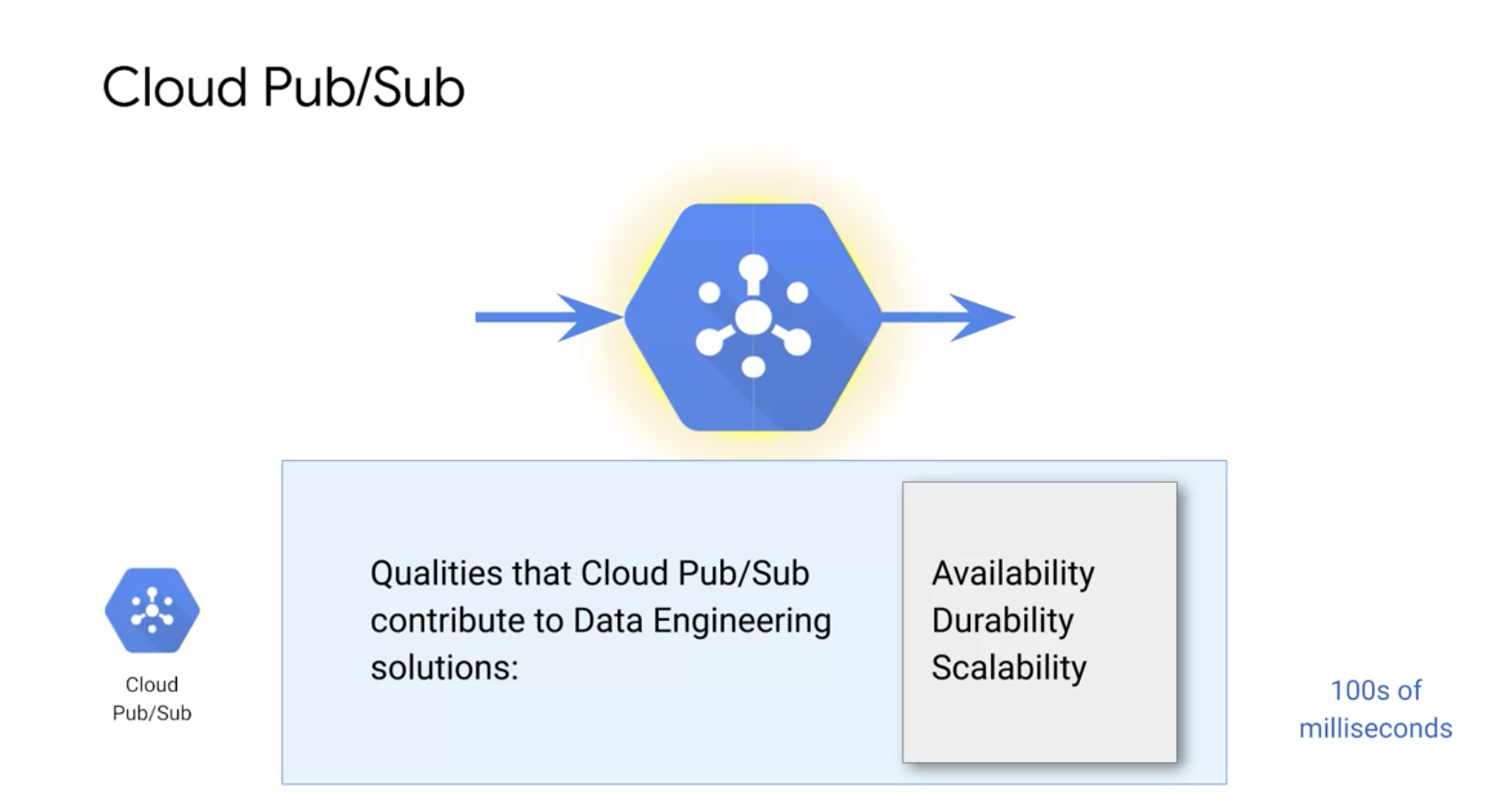

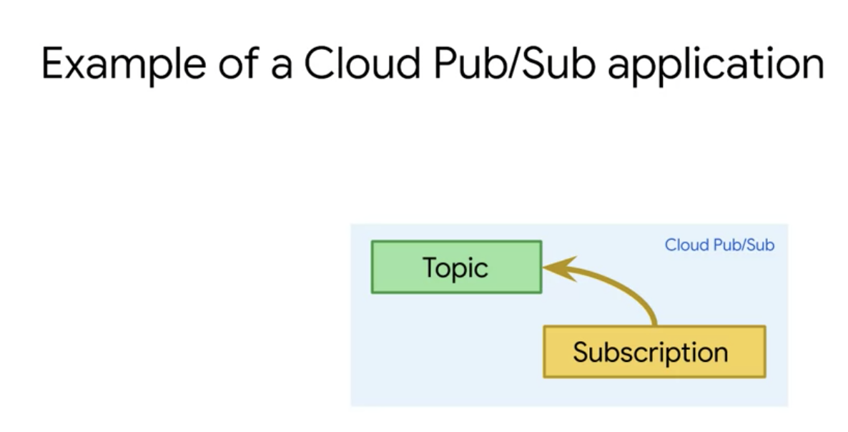

The story of Cloud Pub/Sub is the story of two data structures, the topic and the subscription. Both the topic and the subscription are abstractions which exists in the Pub/Sub framework, independently of any workers, subscribers, or anything else. The Cloud Pub/Sub Client that creates the topic is called the publisher, and the Cloud Pub/Sub Client that creates the subscription is called the subscriber. Publisher will publish events and messages into a topic to be distributed and used for further processing. To receive messages published to a topic, you must create a subscription to that topic.

In this example, the subscription is subscribed to the topic. Only messages published to the topic after the subscription is created are available to subscriber applications. The subscription connects the topic to a subscriber application that receives and processes messages published to the topic. **A topic can have multiple subscriptions, but a given subscription belongs to a single topic.**

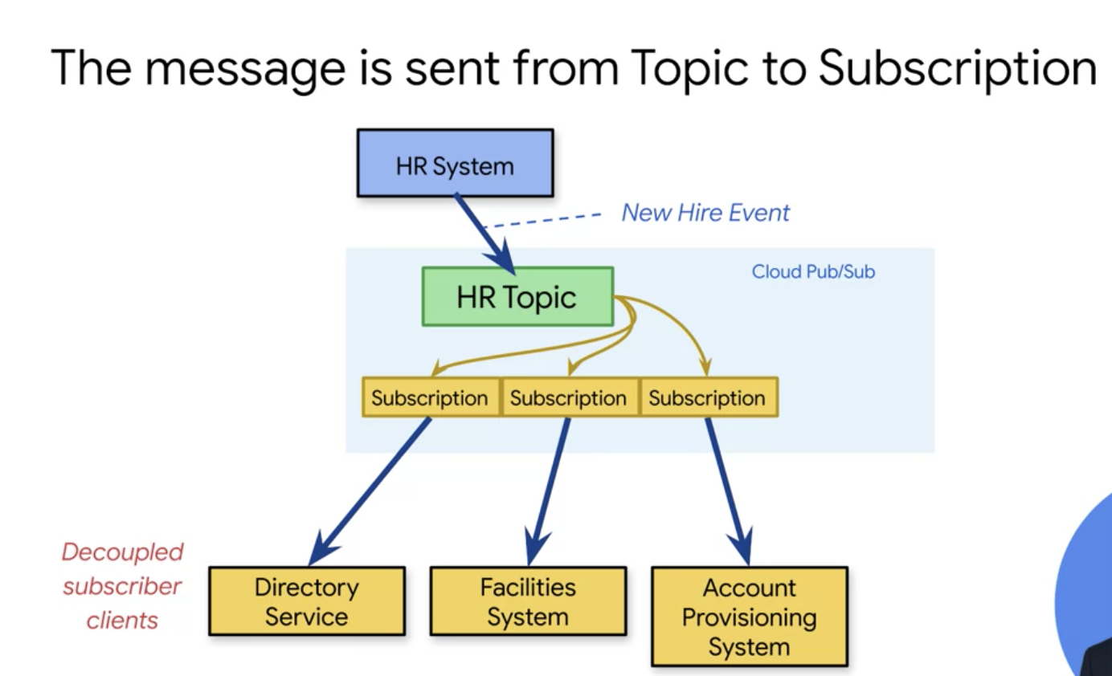

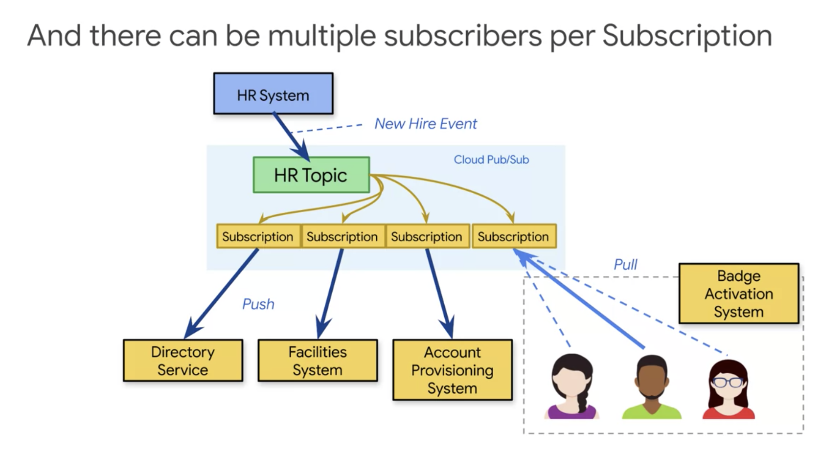

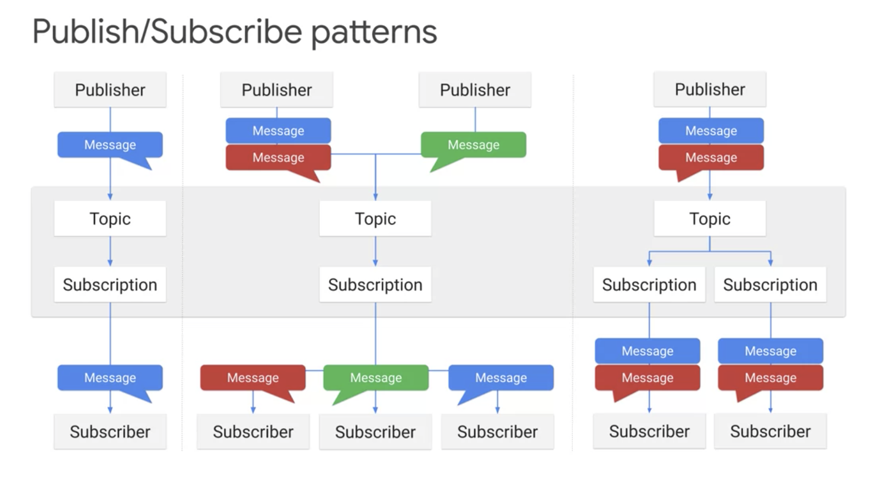

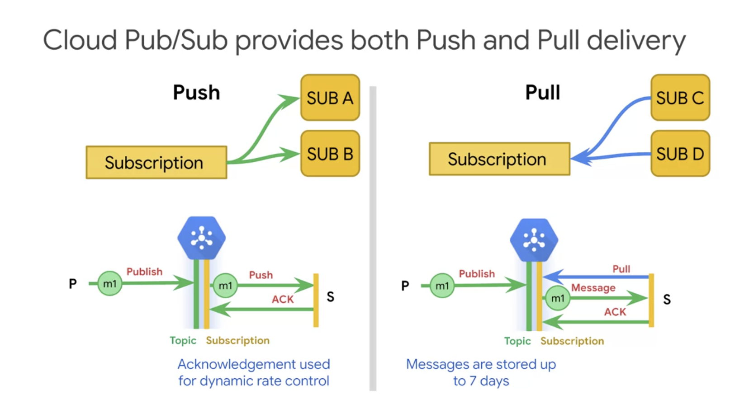

**In the pull model, the messages are stored for up to seven days. In push delivery, Cloud Pub/Sub initiates requests your subscriber application, to deliver messages. The Cloud Pub/Sub servers sends each message as an HTTPS request to the subscriber application at a preconfigured endpoint.**

**In the push scenario, you just respond with status 200 Okay for the HTTP call, and that tells Pub/Sub the message delivery was successful.**

**Push delivery is ideal when multiple topics must be processed by the same webhook for example.**

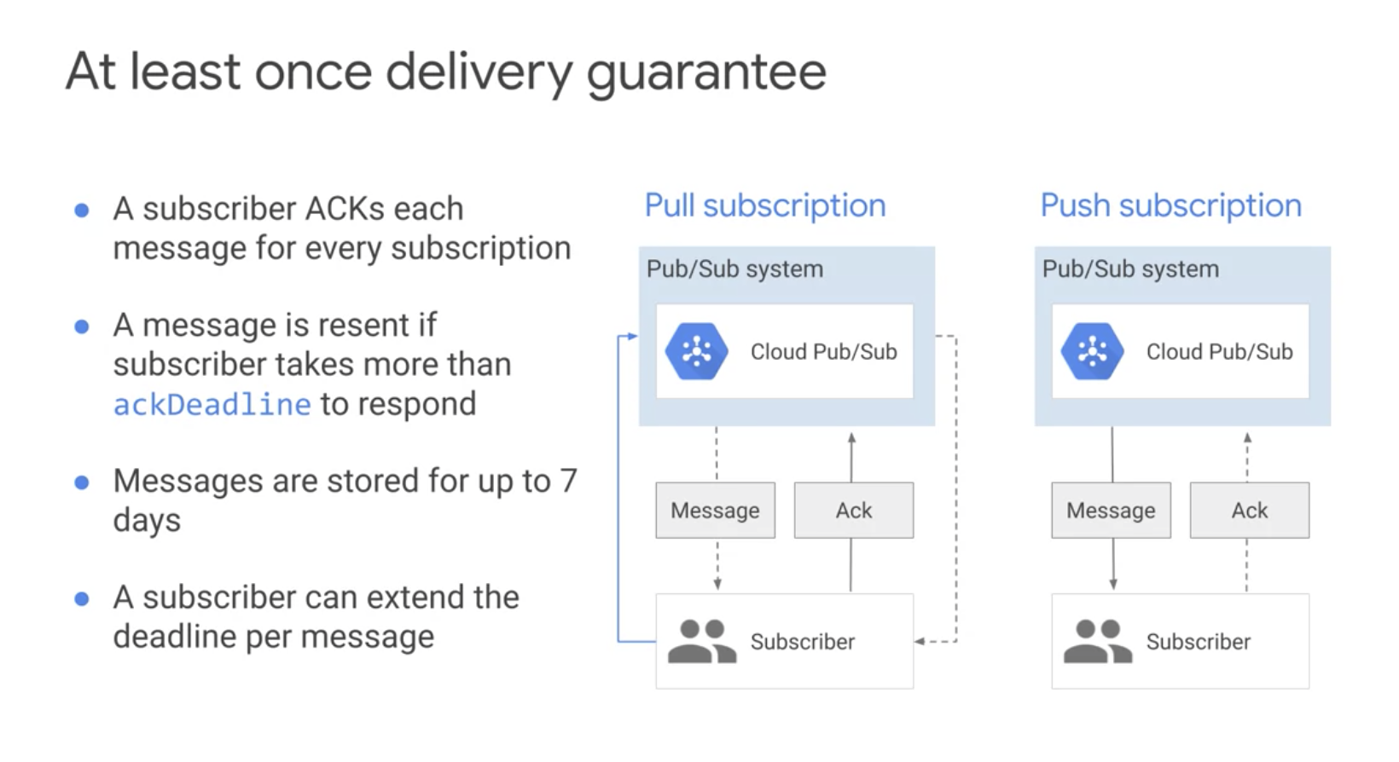

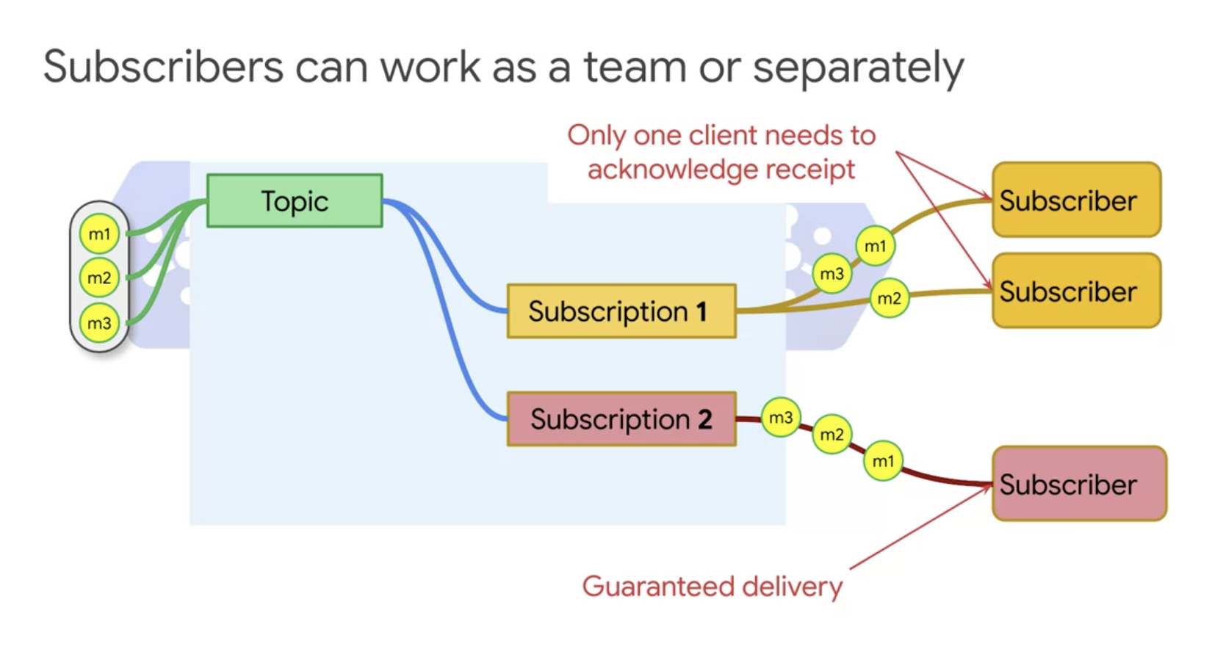

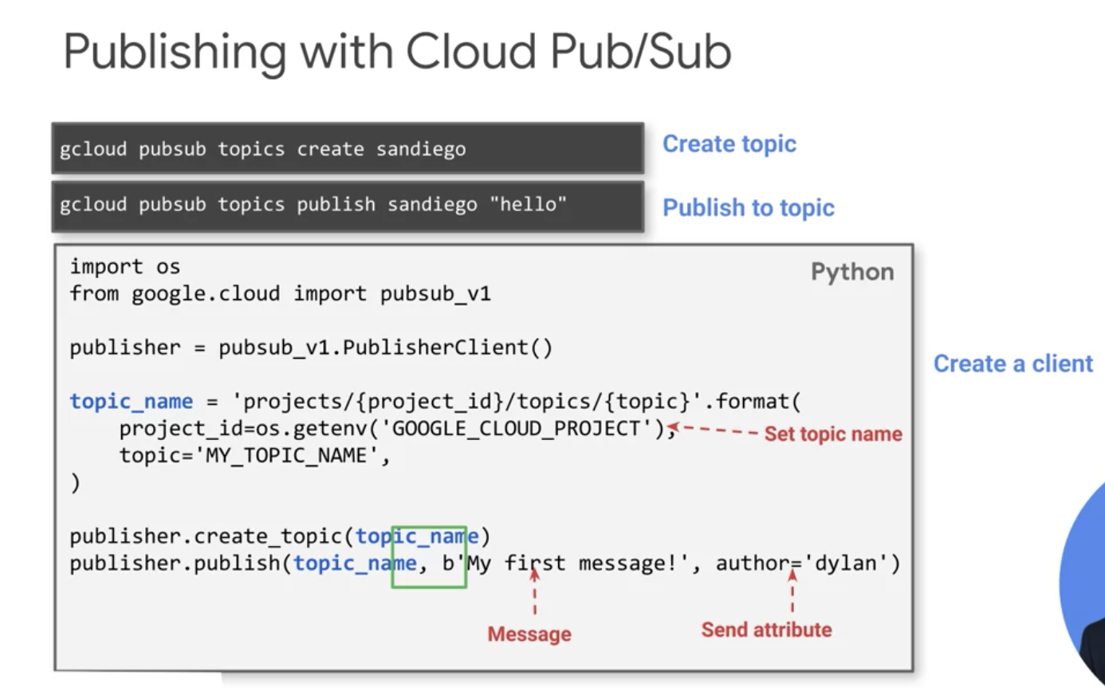

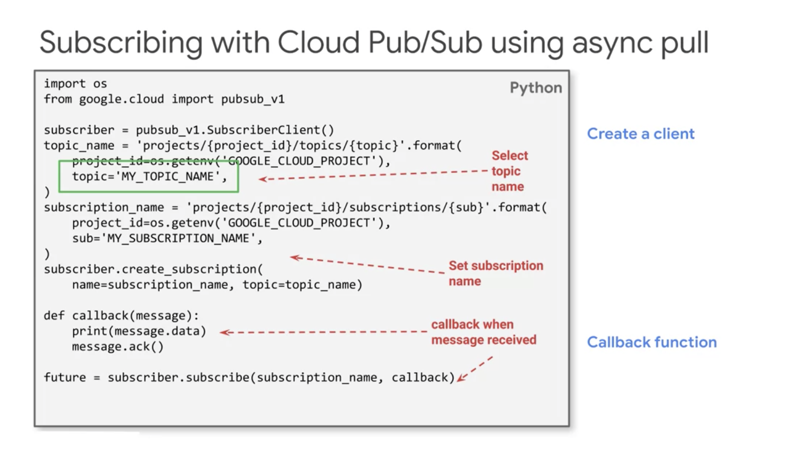

**In general, asynchronous pull is preferable for latency sensitive applications.**

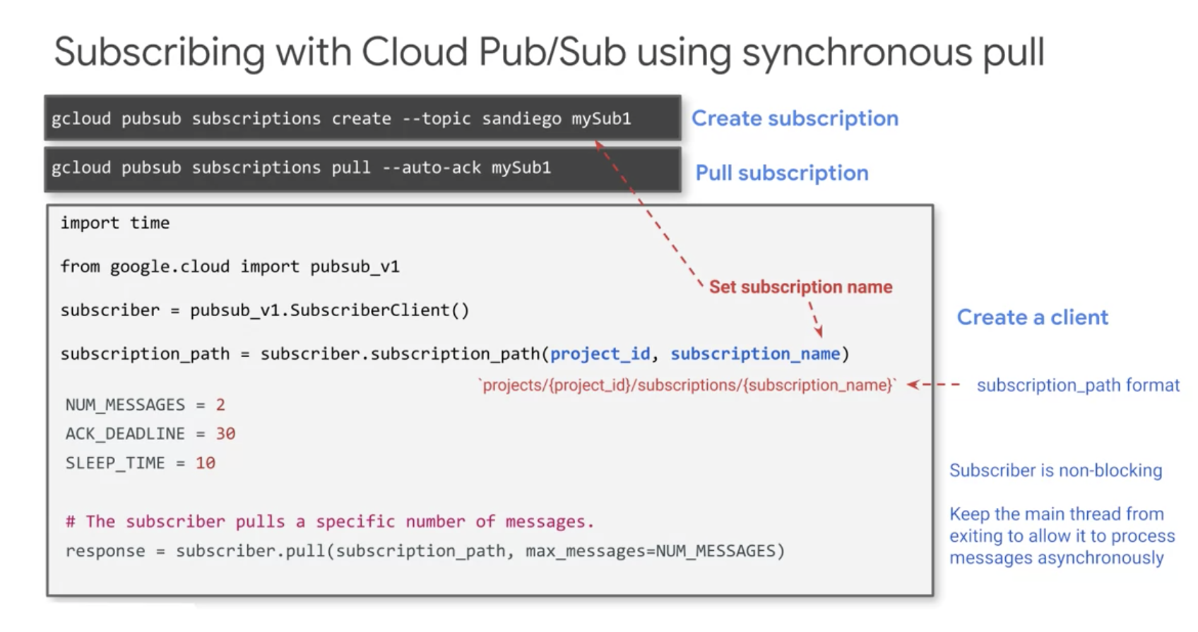

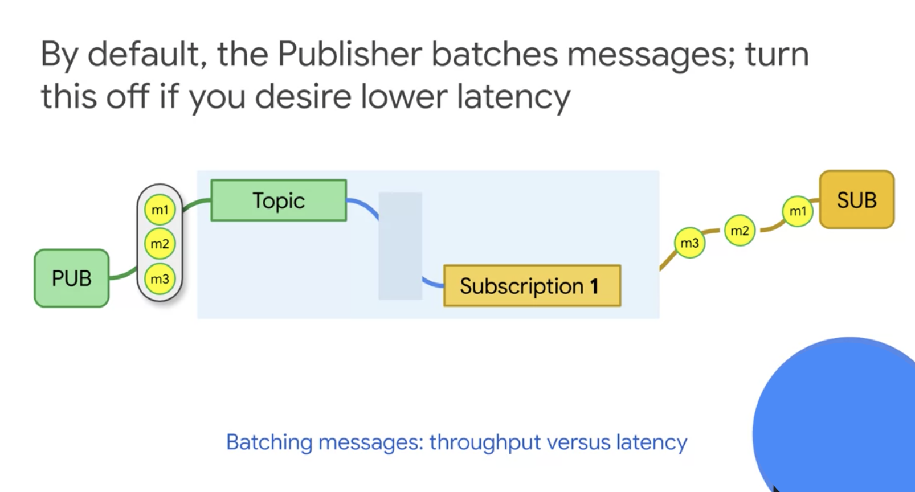

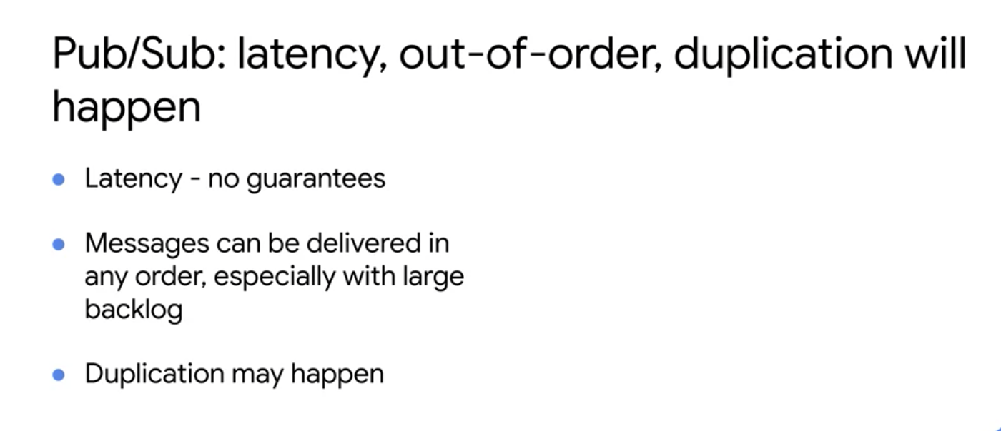

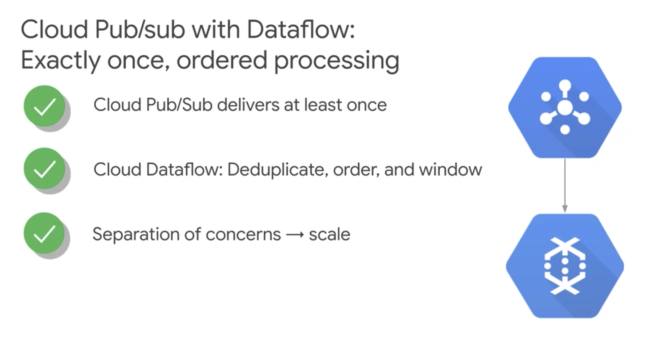

* Dataflow will de-duplicate messages based on the message ID because in Pub/Sub, if a message is delivered twice, it will have the same ID in both cases.
* BigQuery can also be used for this purpose but has limited capabilities.
* Data flow will not be able to order in the sense of providing exact sequential order of when messages were published. However, it will help us deal with late data.
* Using Pub/Sub and Dataflow together allows us to get a scale at that wouldn't be possible otherwise.

**Create Pub/Sub topic and subscription**

git clone https://github.com/GoogleCloudPlatform/training-data-analyst

1. On the **training-vm** SSH terminal, navigate to the directory for this lab.

cd ~/training-data-analyst/courses/streaming/publish

1. Create your topic and publish a simple message.

gcloud pubsub topics create sandiego

1. Publish a simple message.

gcloud pubsub topics publish sandiego --message "hello"

1. Create a subscription for the topic.

gcloud pubsub subscriptions create --topic sandiego mySub1

1. Pull the first message that was published to your topic.

gcloud pubsub subscriptions pull --auto-ack mySub1

Do you see any result? If not, why?

1. Try to publish another message and then pull it using the subscription.

gcloud pubsub topics publish sandiego --message "hello again"

gcloud pubsub subscriptions pull --auto-ack mySub1

Did you get any response this time?

Output:

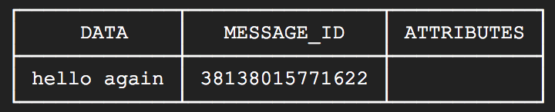

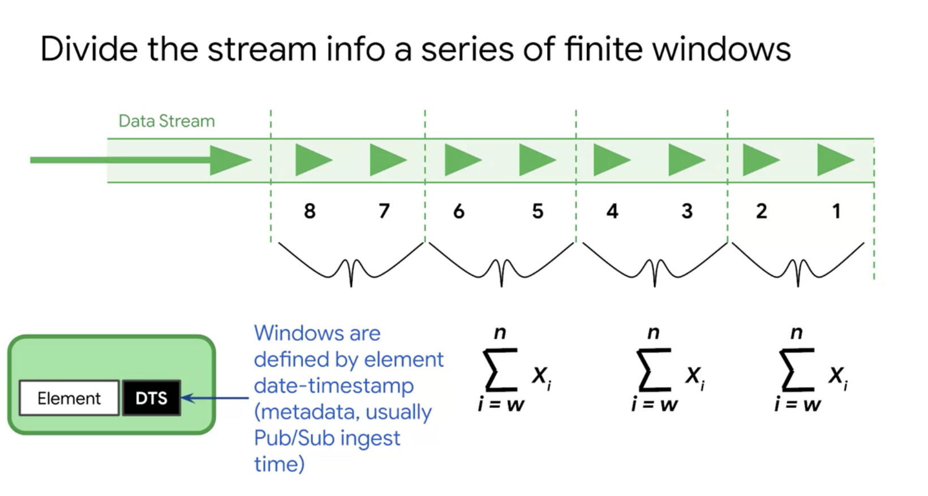

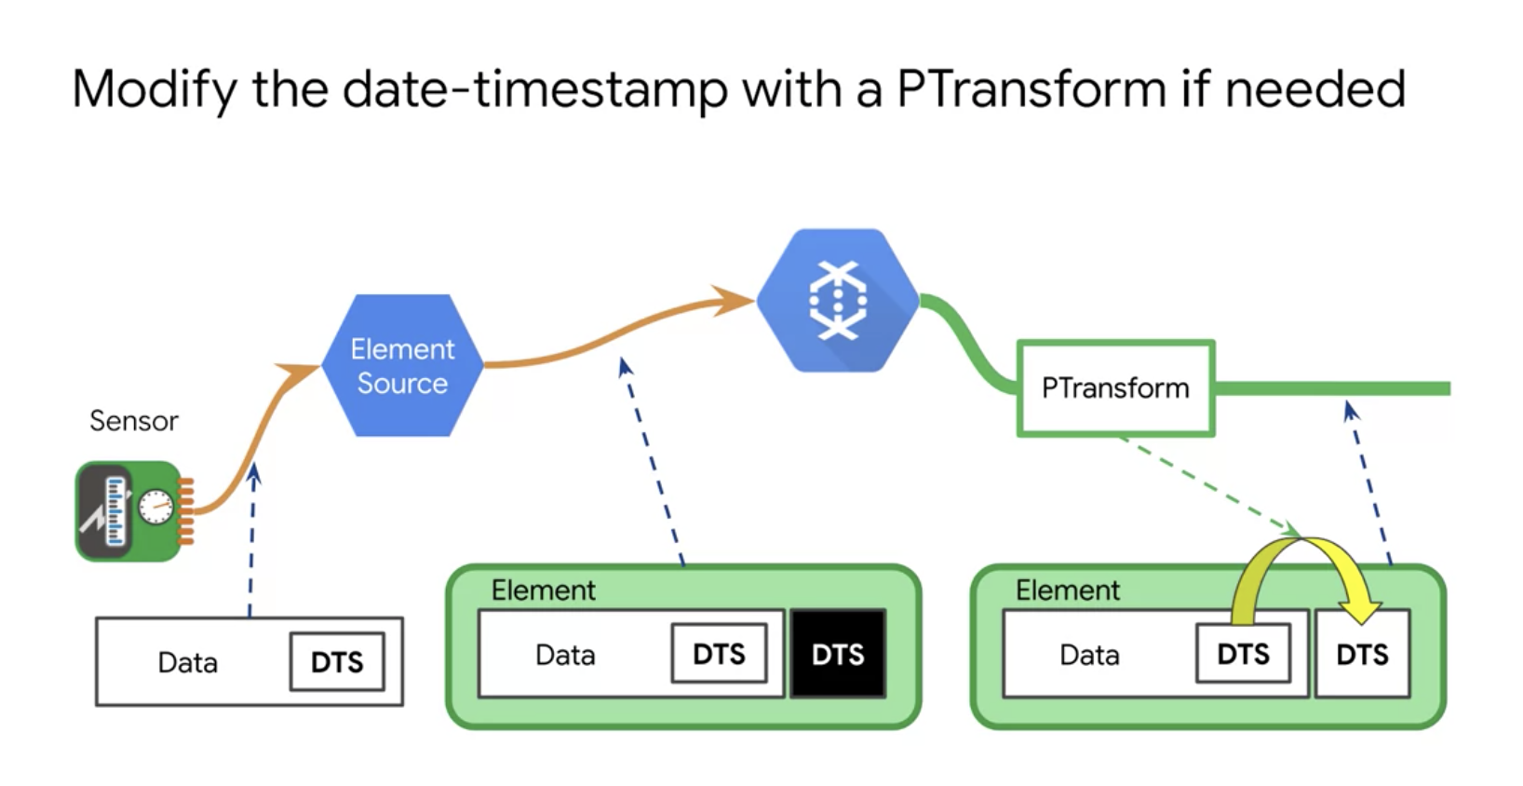

# Cloud Dataflow Windowing

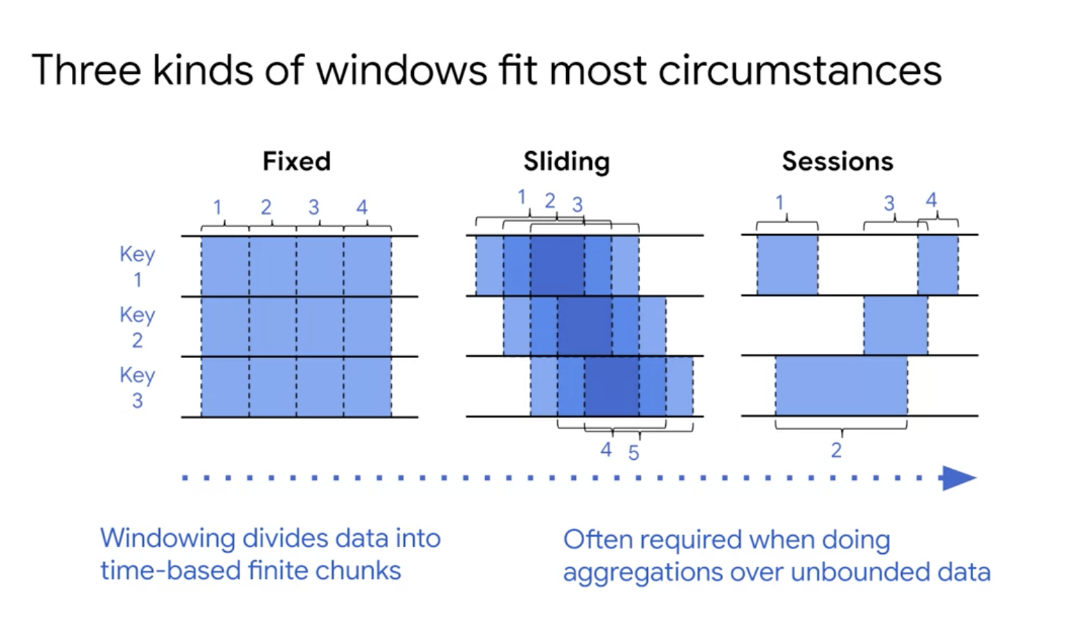

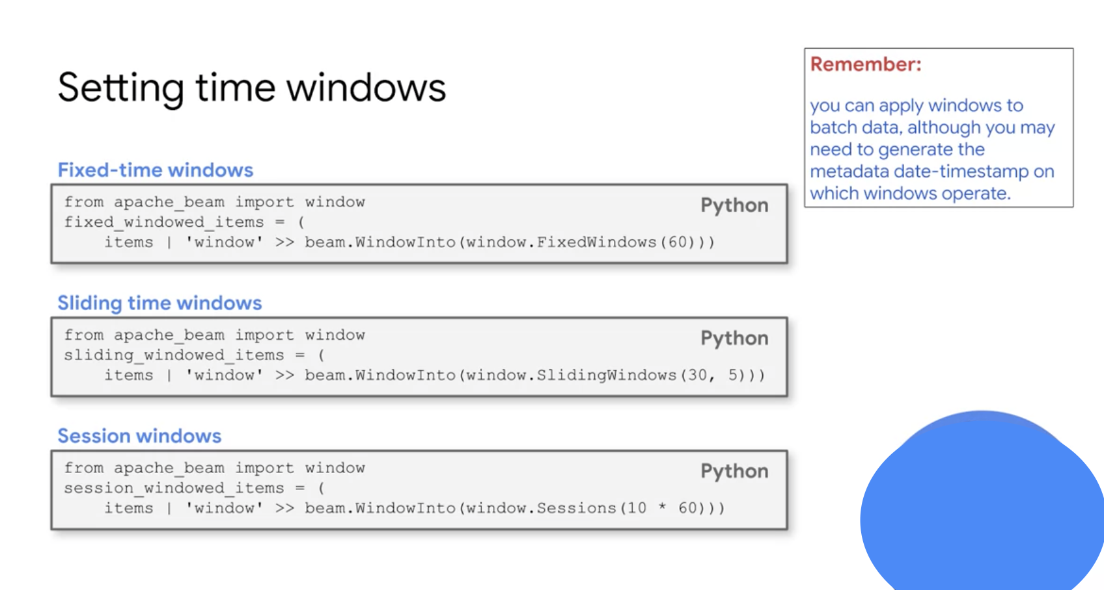

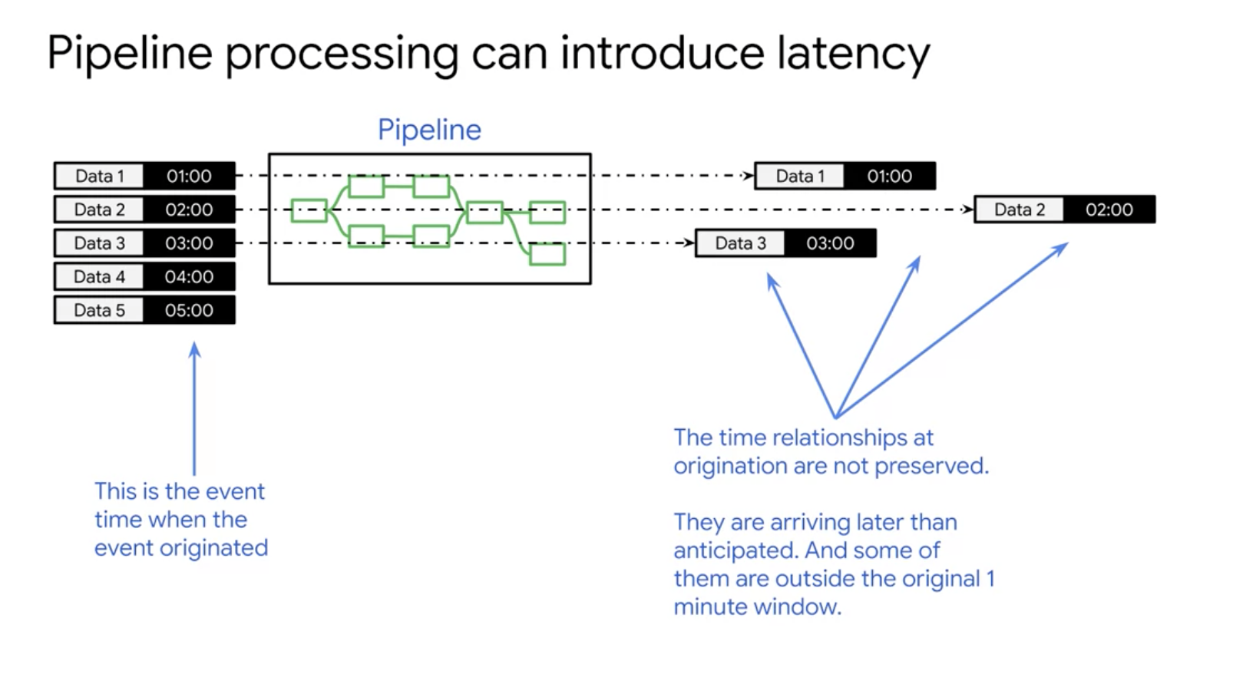

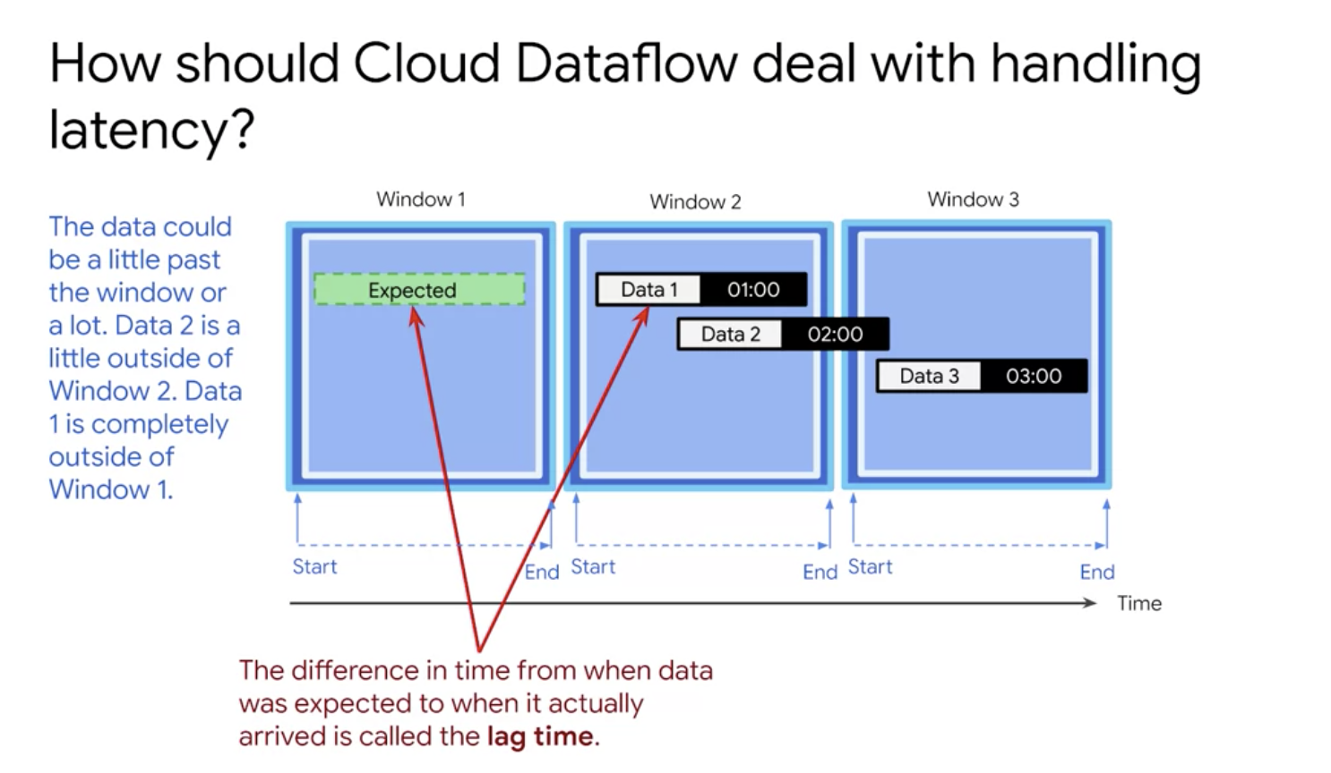

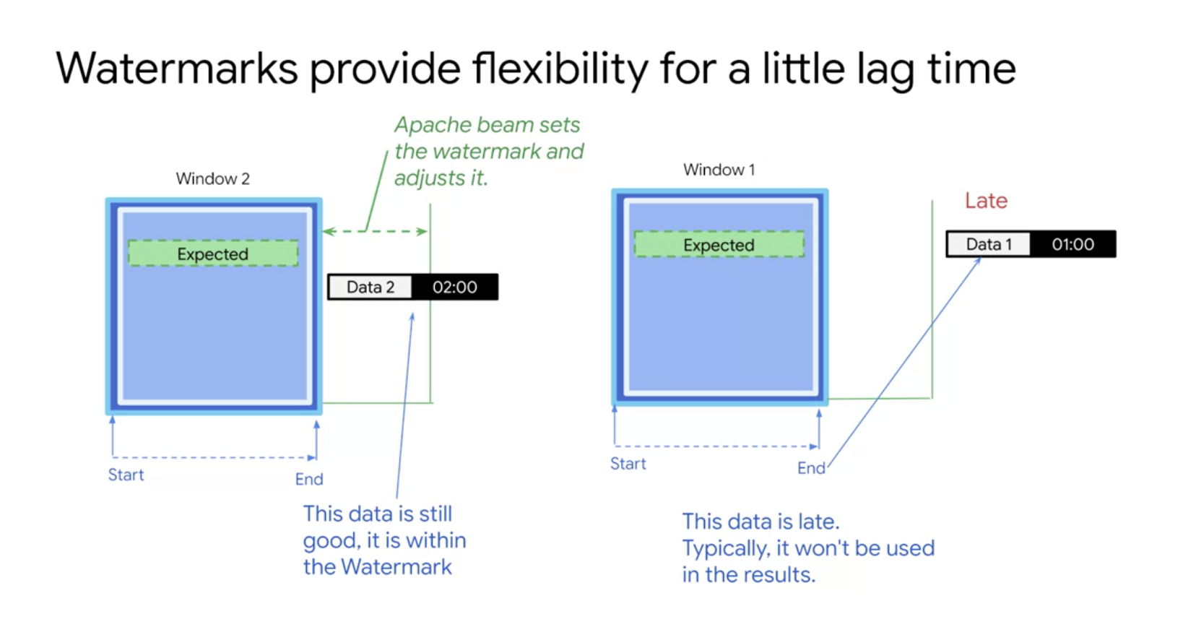

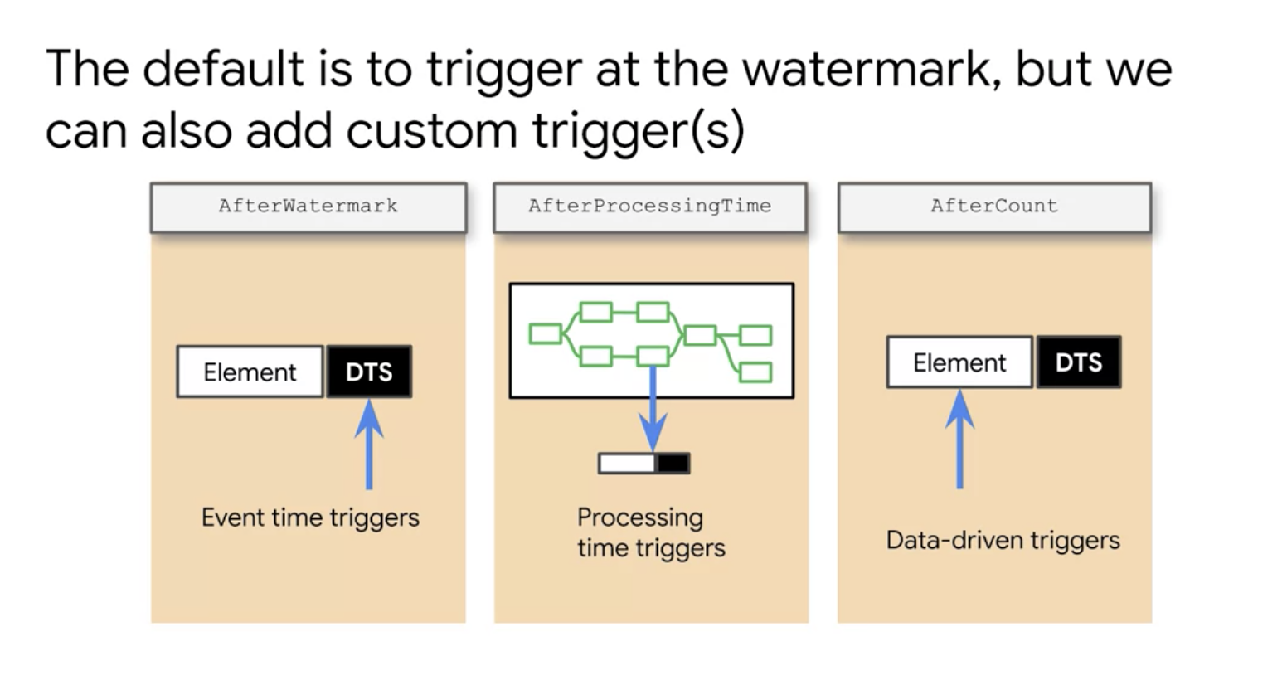

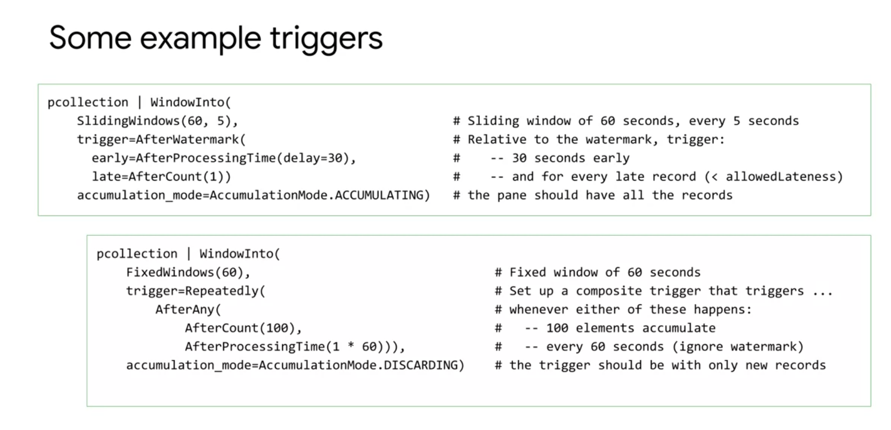

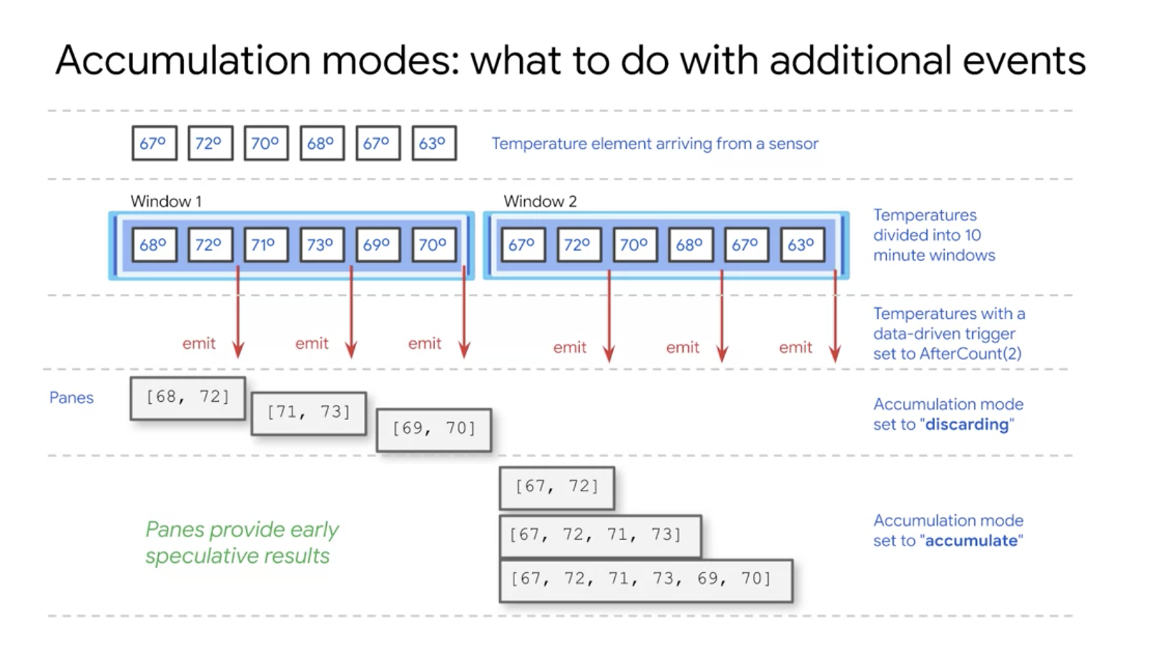

To Create a dataflow pipeline =>

<https://github.com/GoogleCloudPlatform/training-data-analyst/blob/master/courses/streaming/process/sandiego/run_oncloud.sh>

Example Dataflow pipelines =>

<https://github.com/GoogleCloudPlatform/training-data-analyst/blob/master/courses/streaming/process/sandiego/src/main/java/com/google/cloud/training/dataanalyst/sandiego/AverageSpeeds.java>

<https://github.com/GoogleCloudPlatform/training-data-analyst/blob/master/courses/streaming/process/sandiego/src/main/java/com/google/cloud/training/dataanalyst/sandiego/CurrentConditions.java>

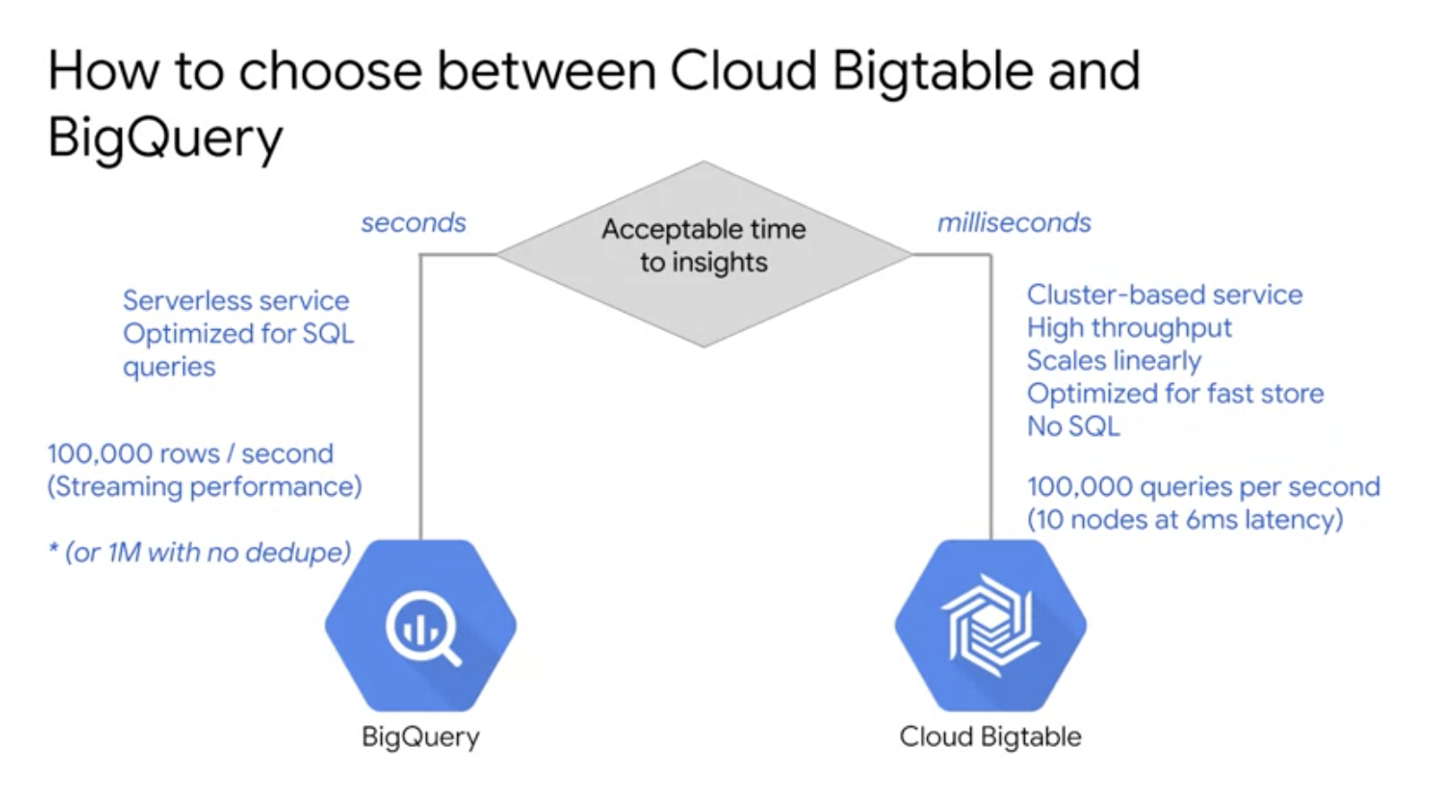

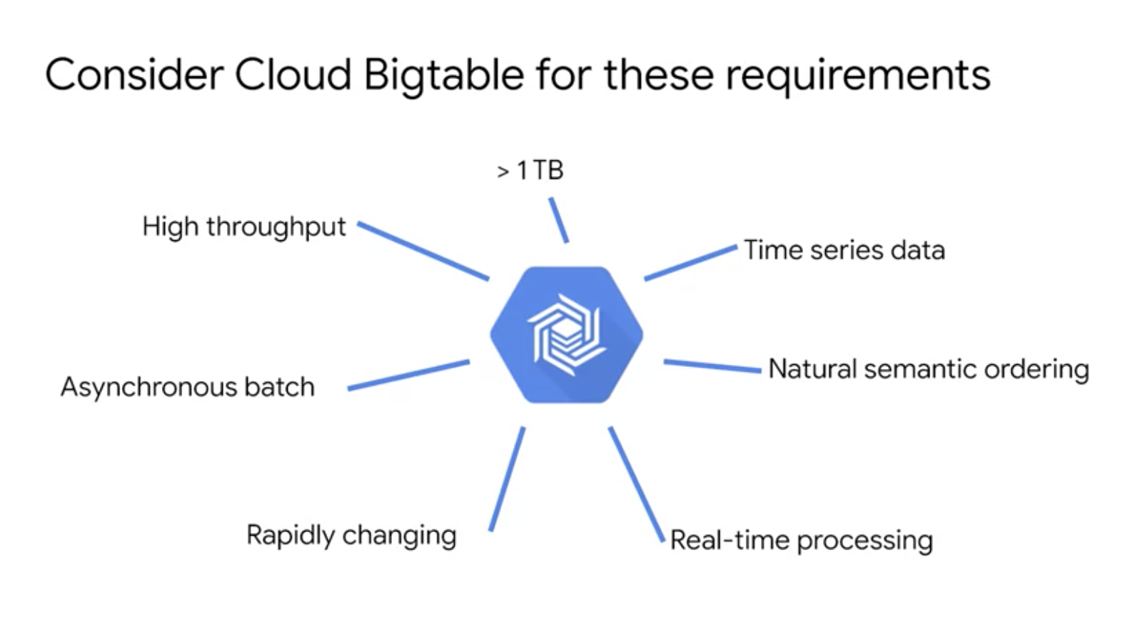

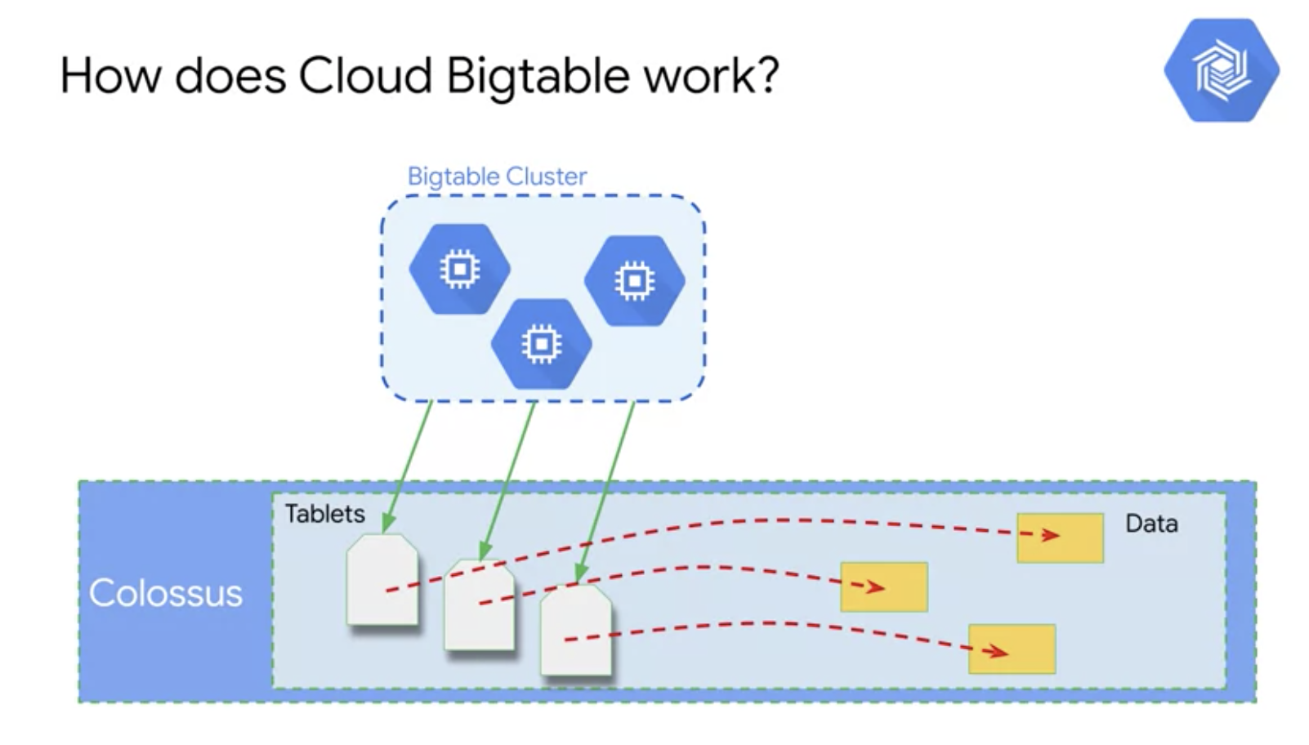

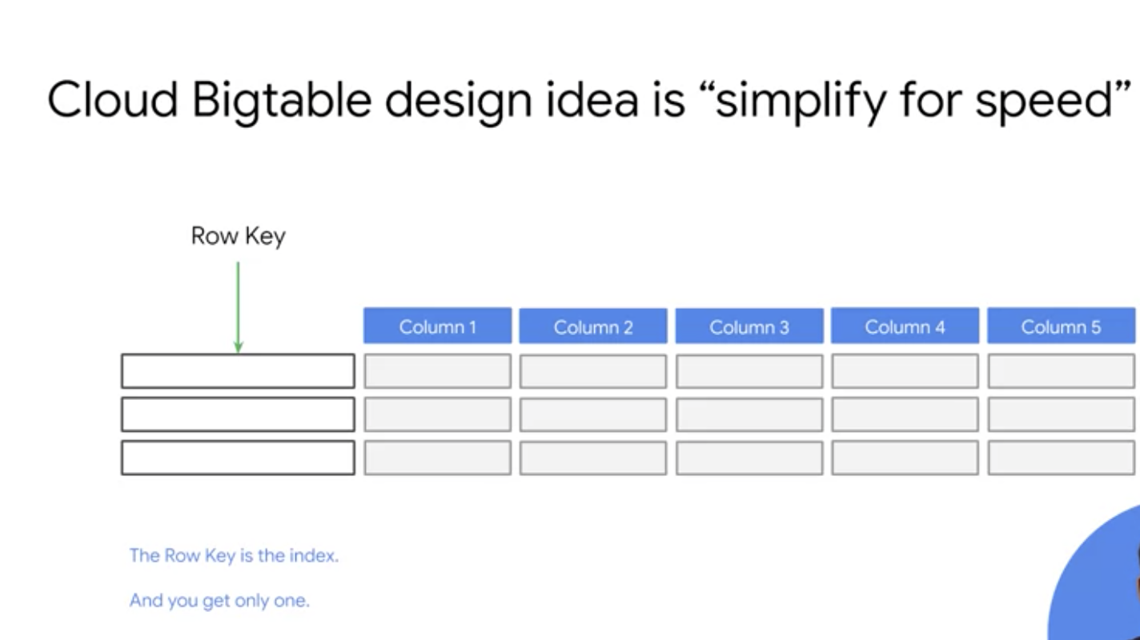

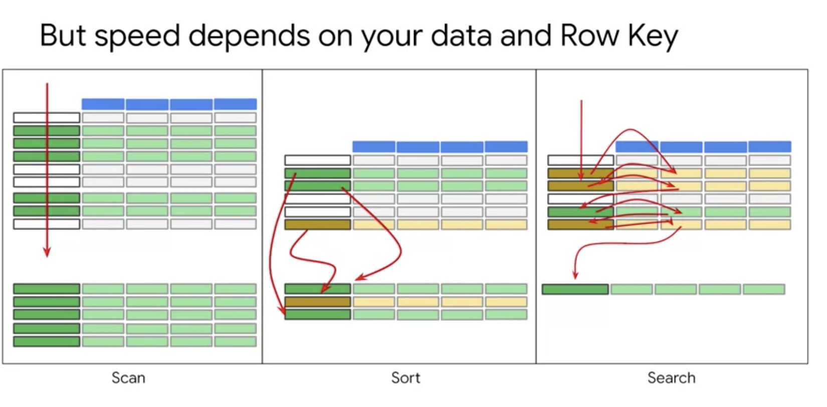

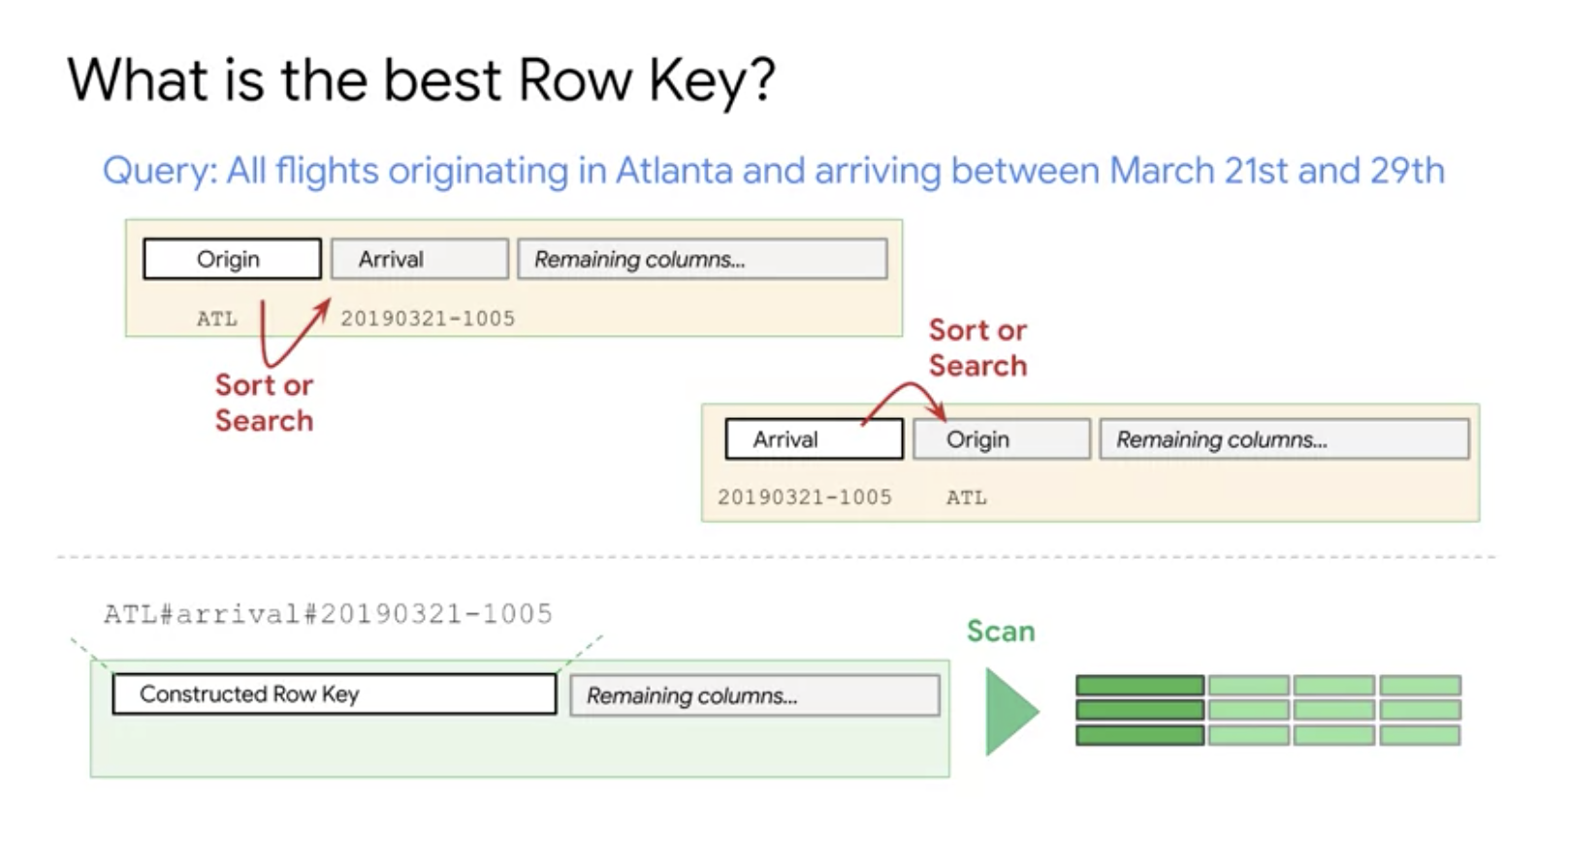

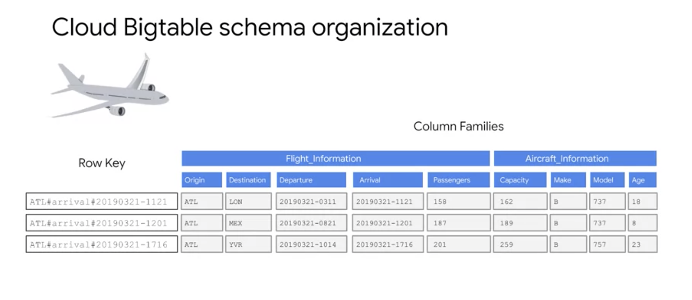

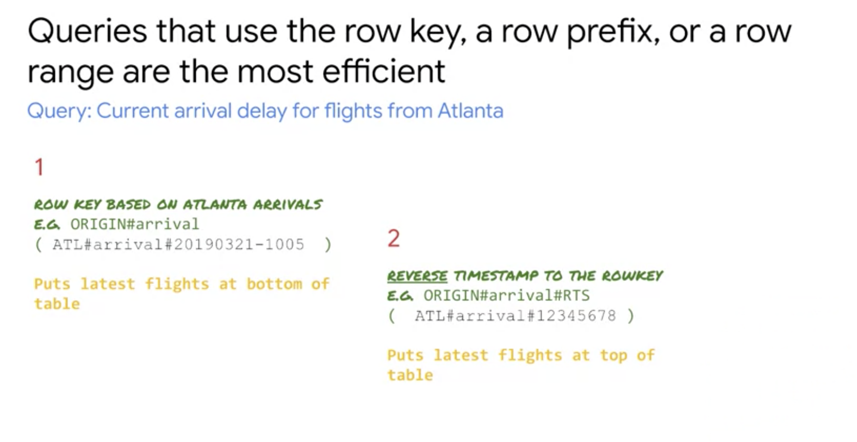

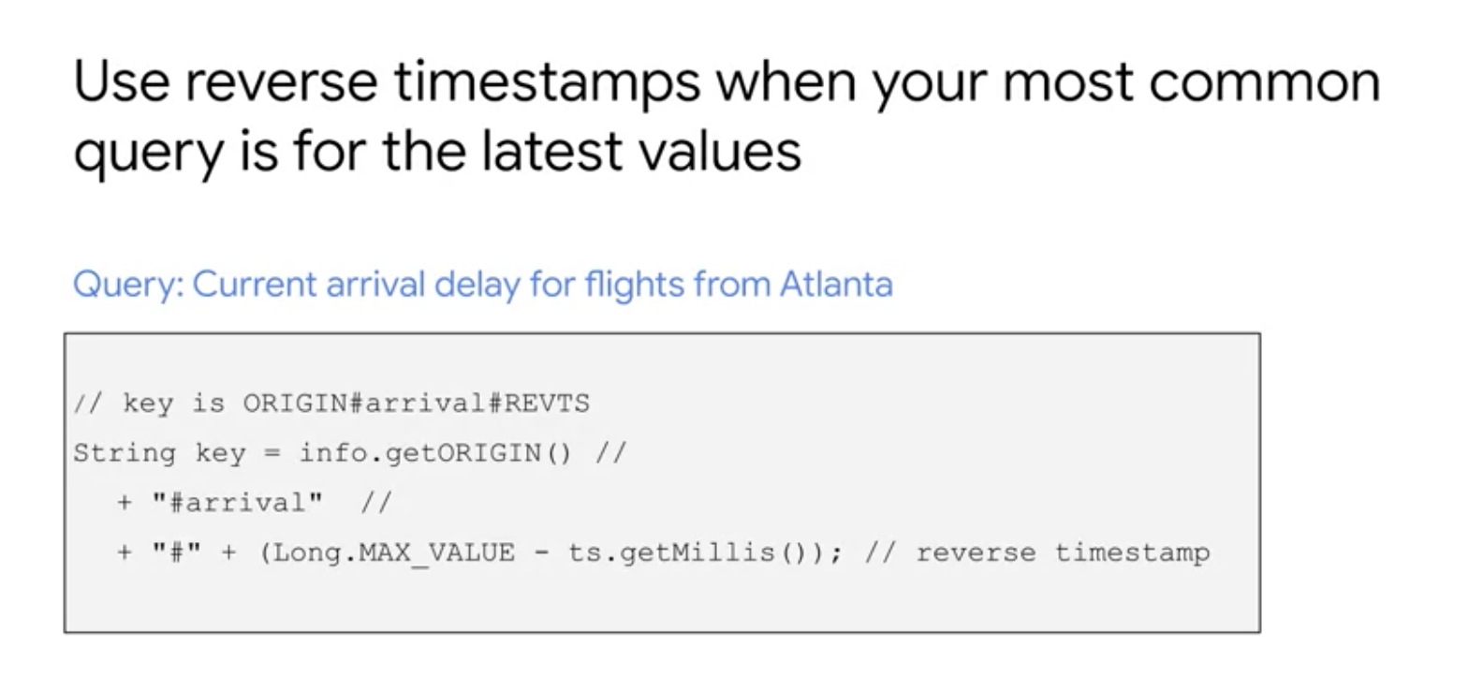

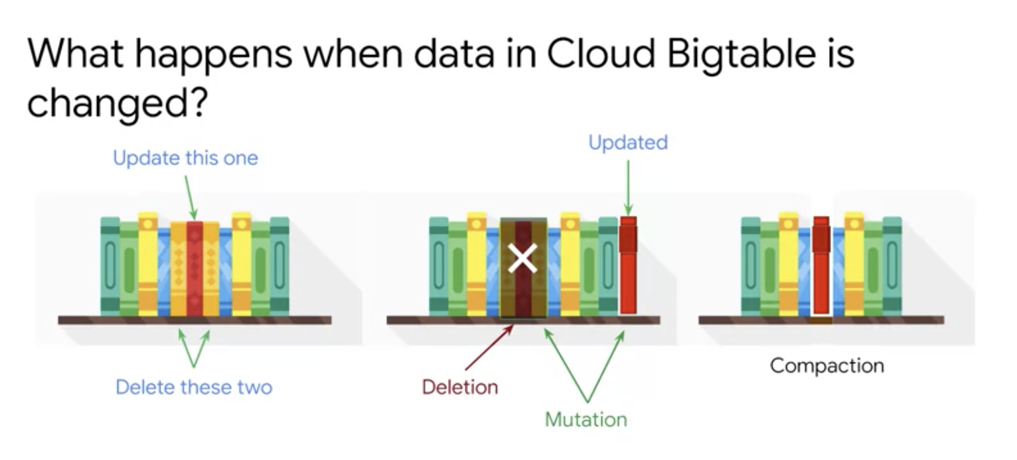

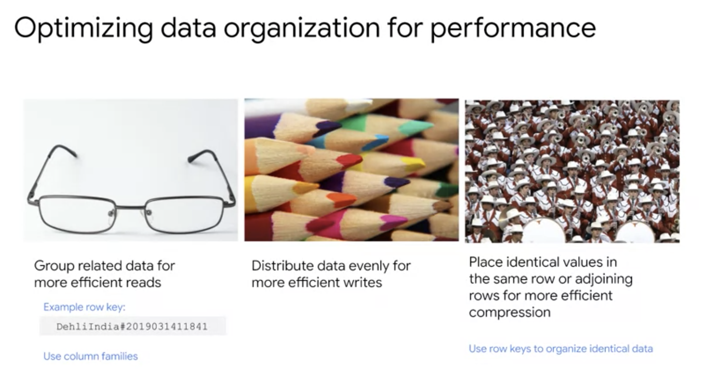

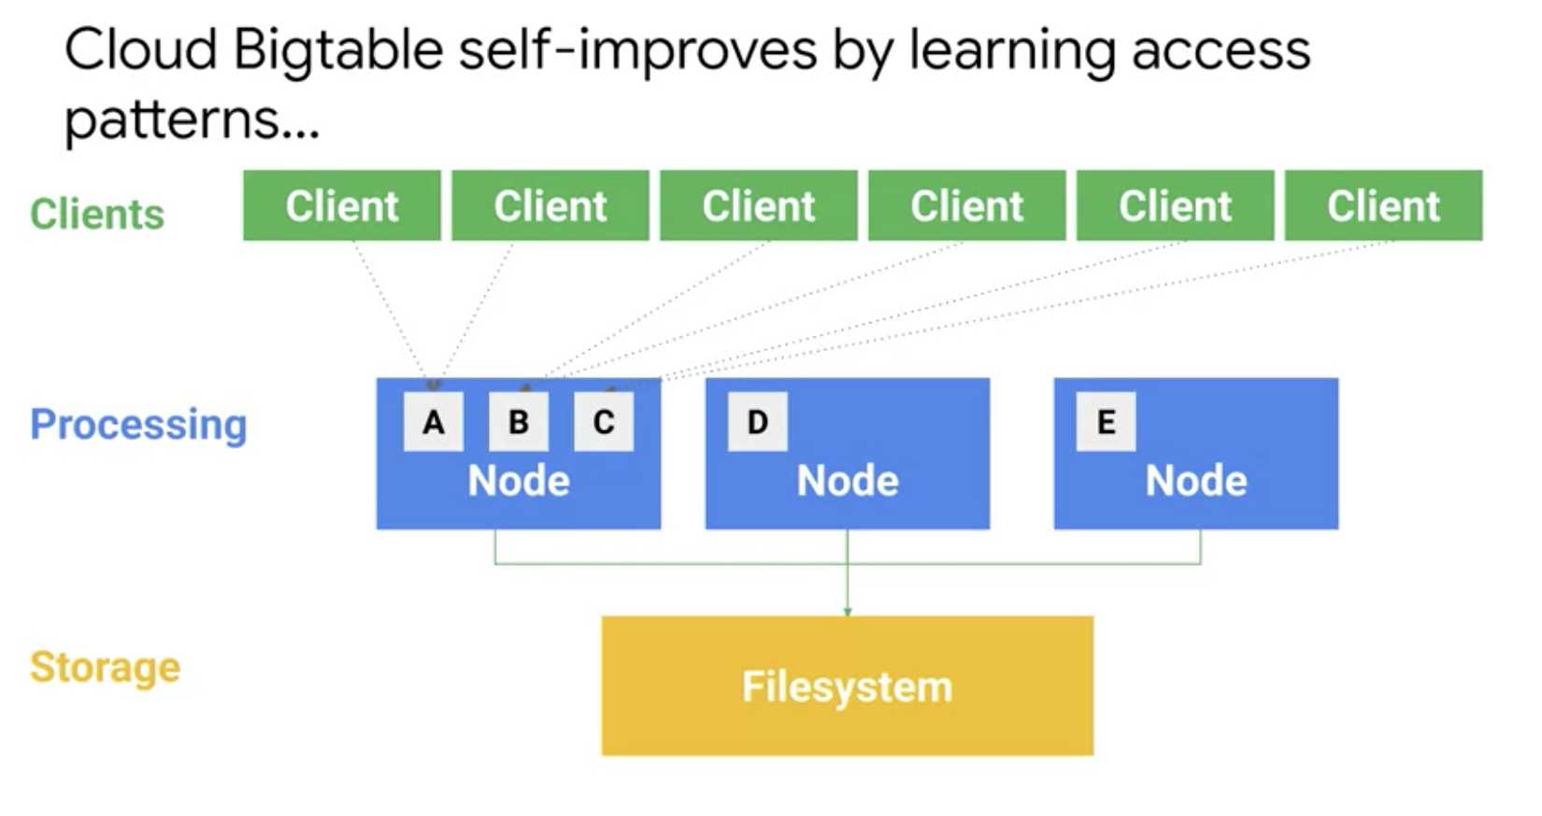

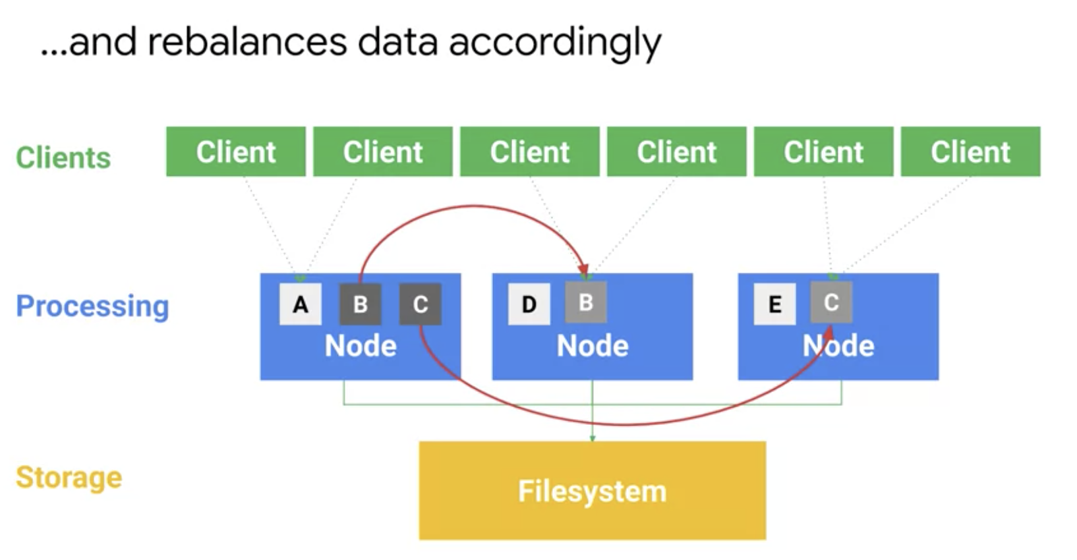

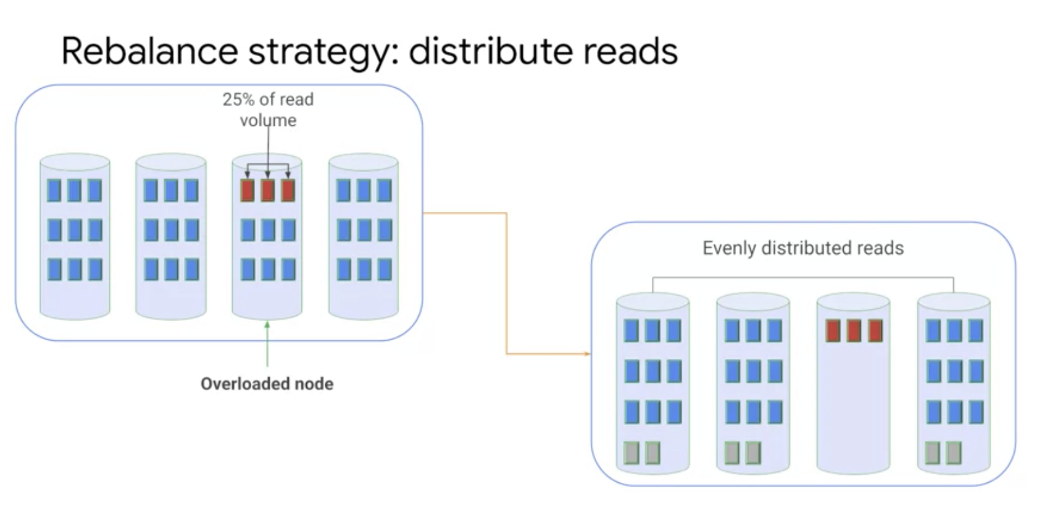

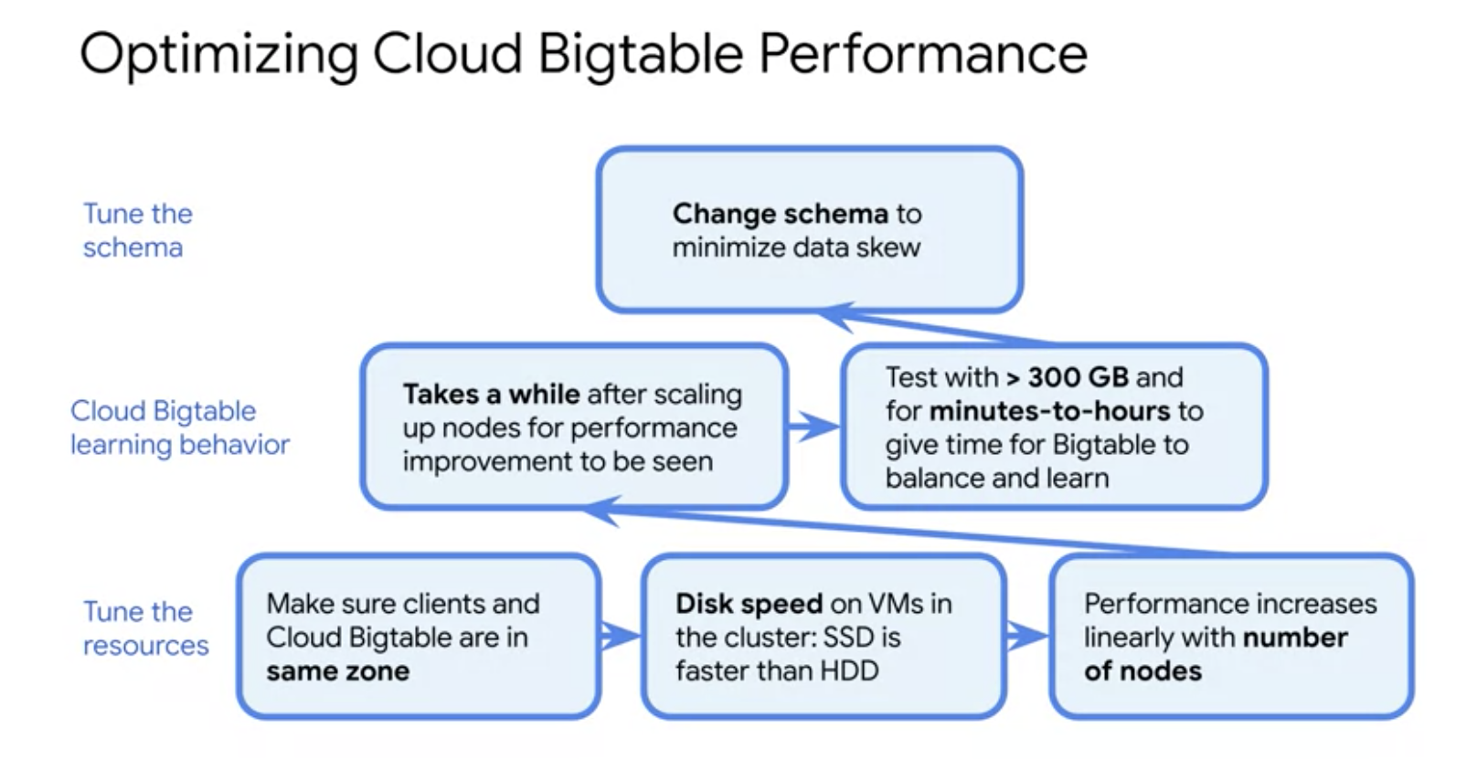

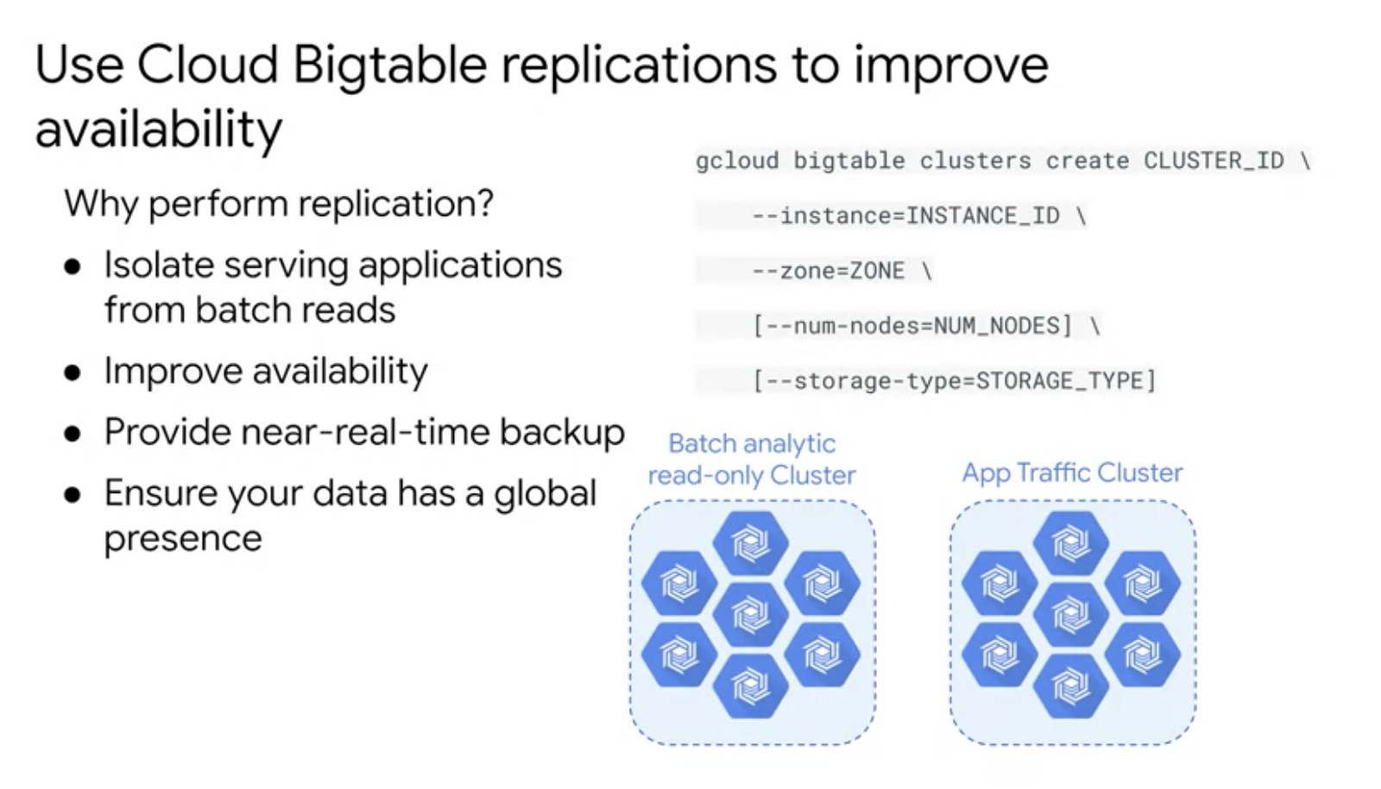

GIS Functions =>

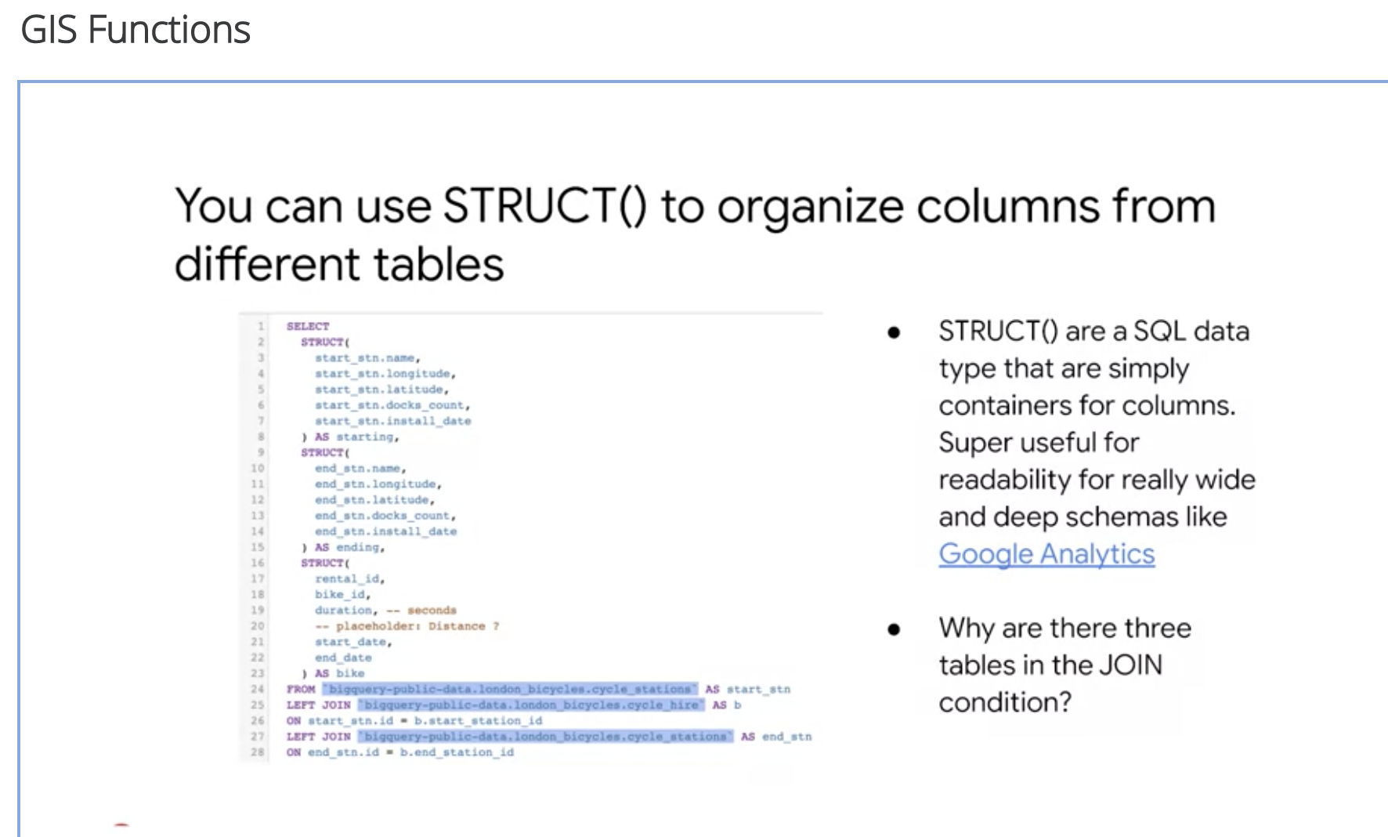

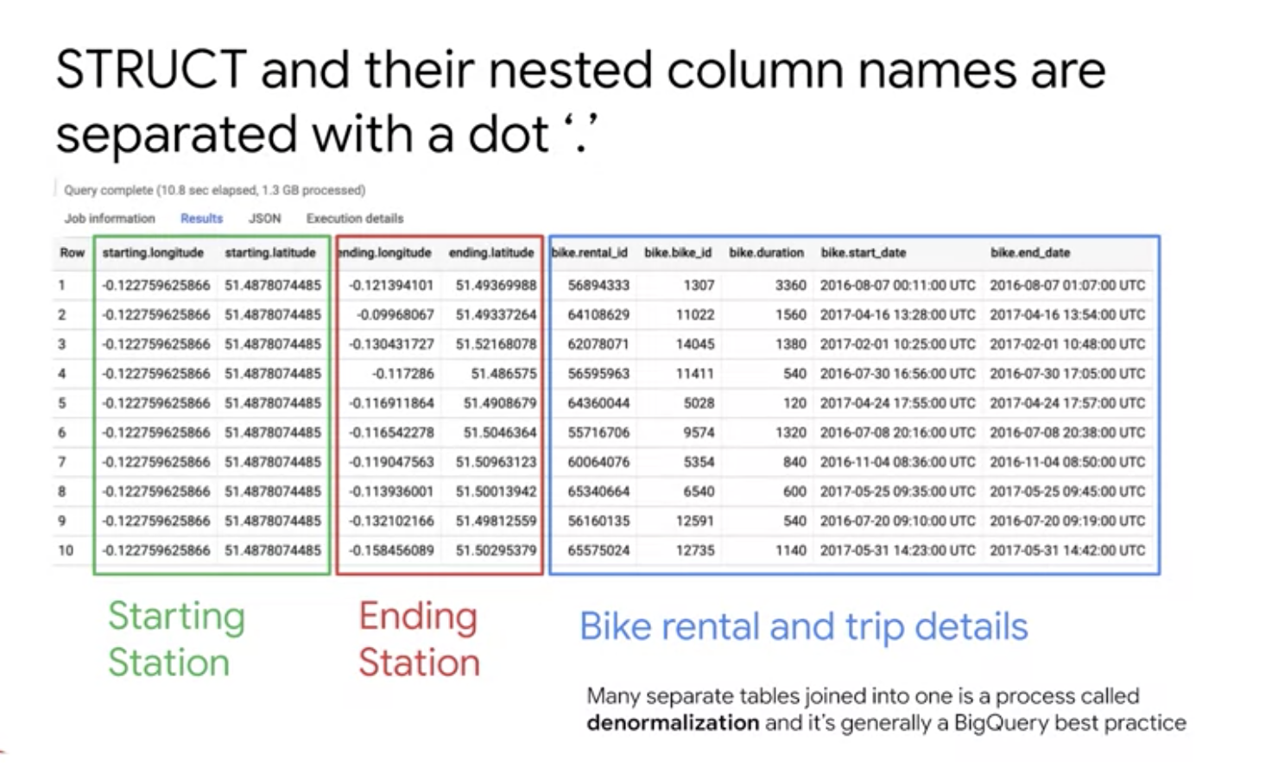

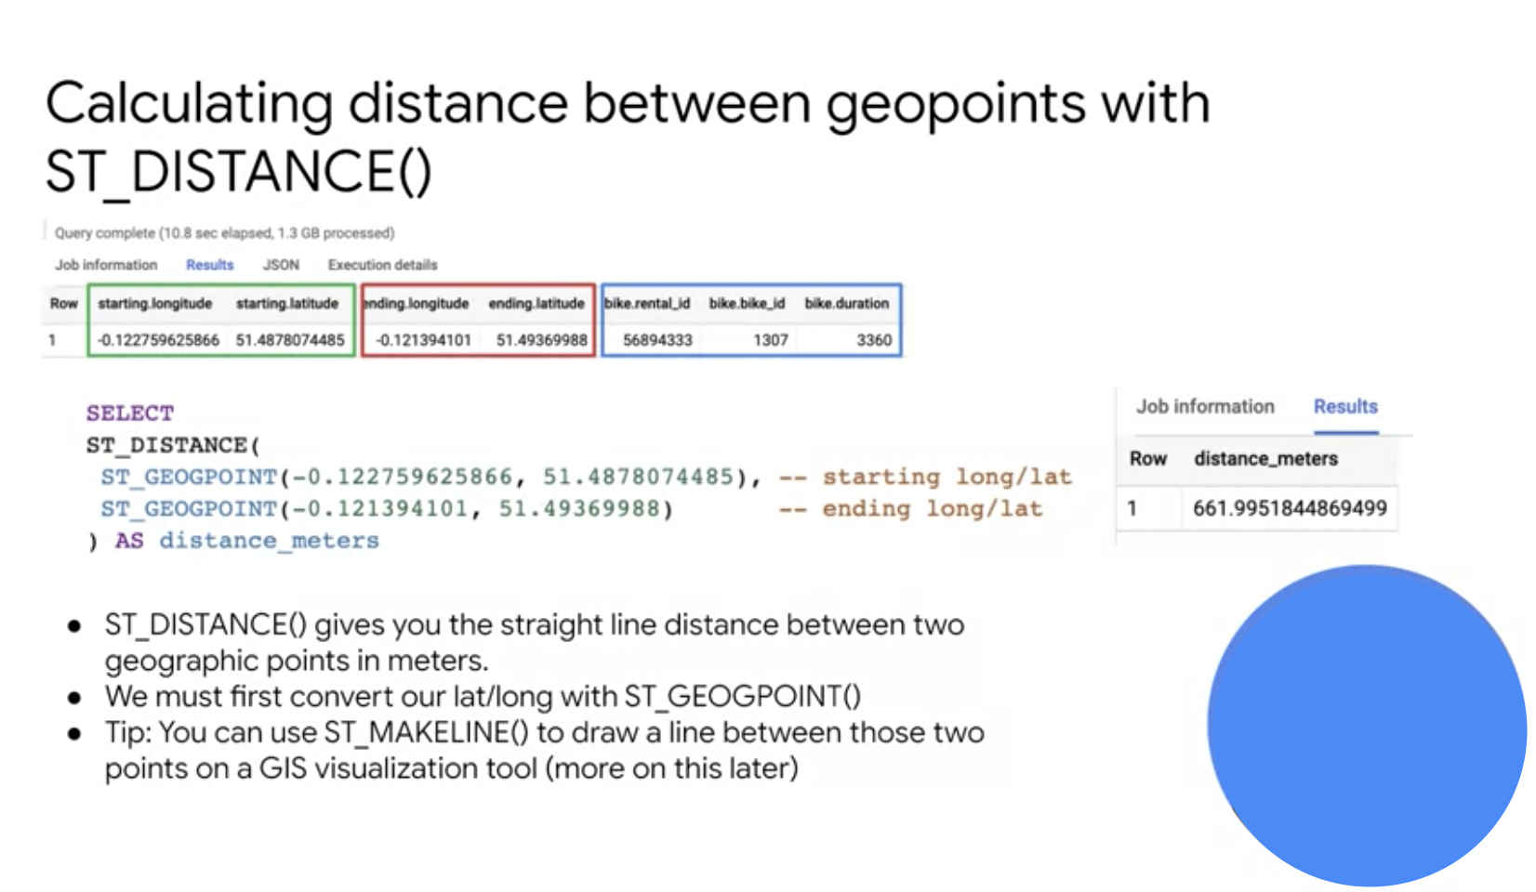

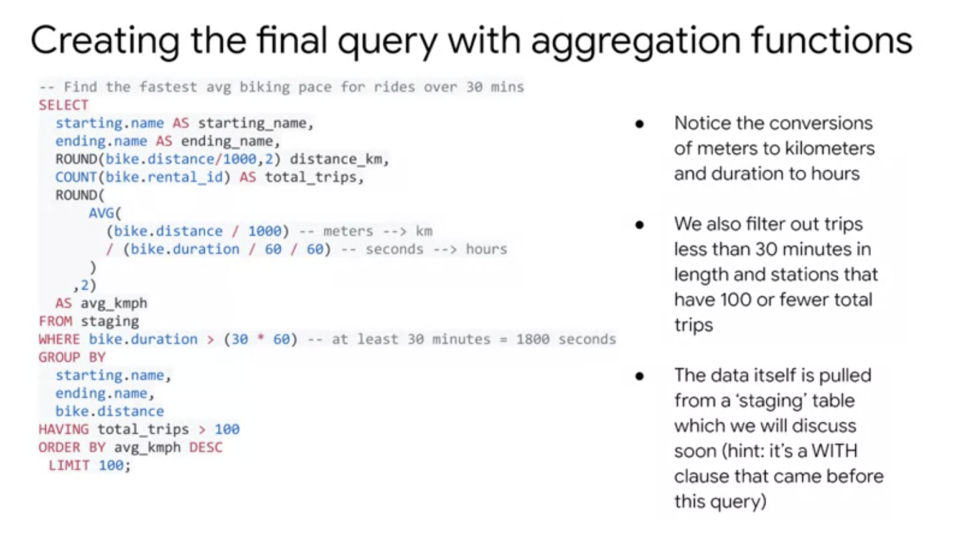

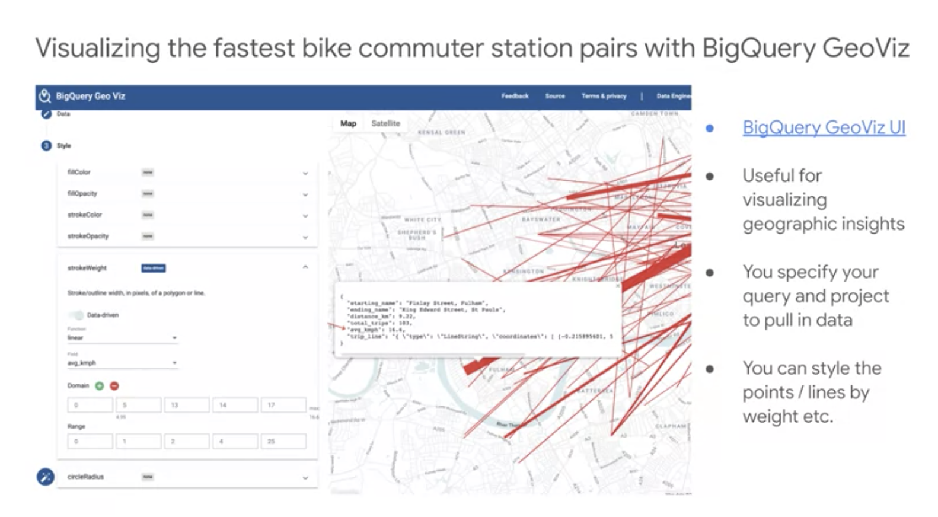

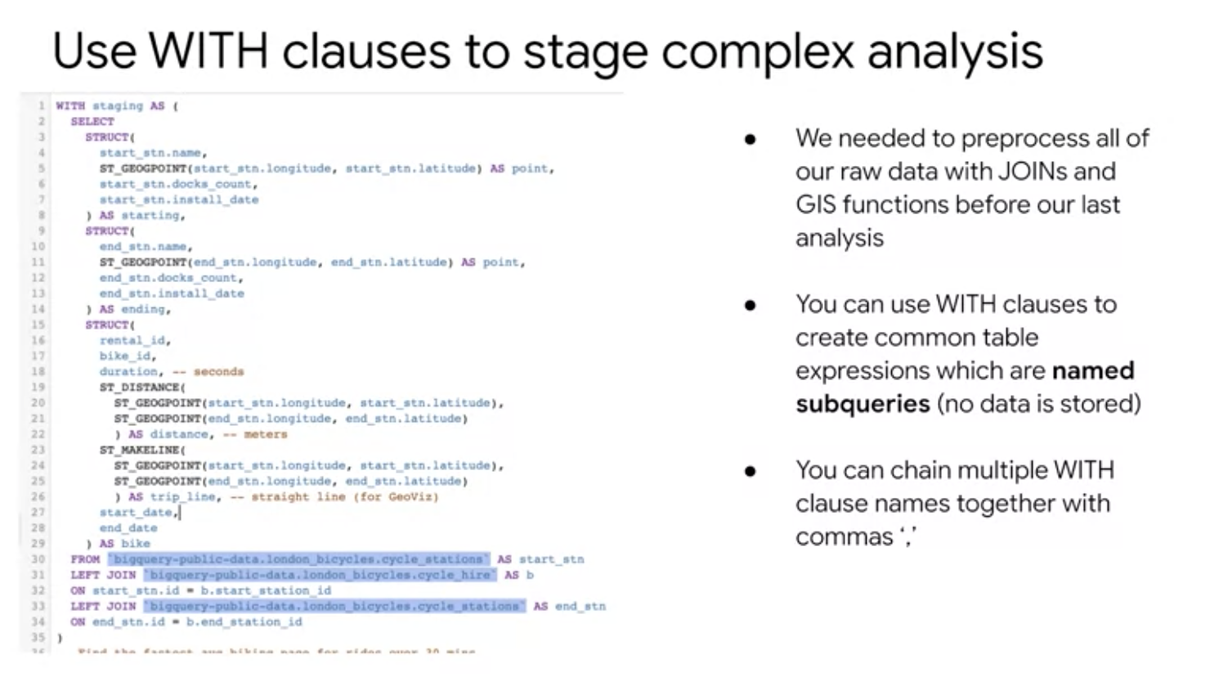

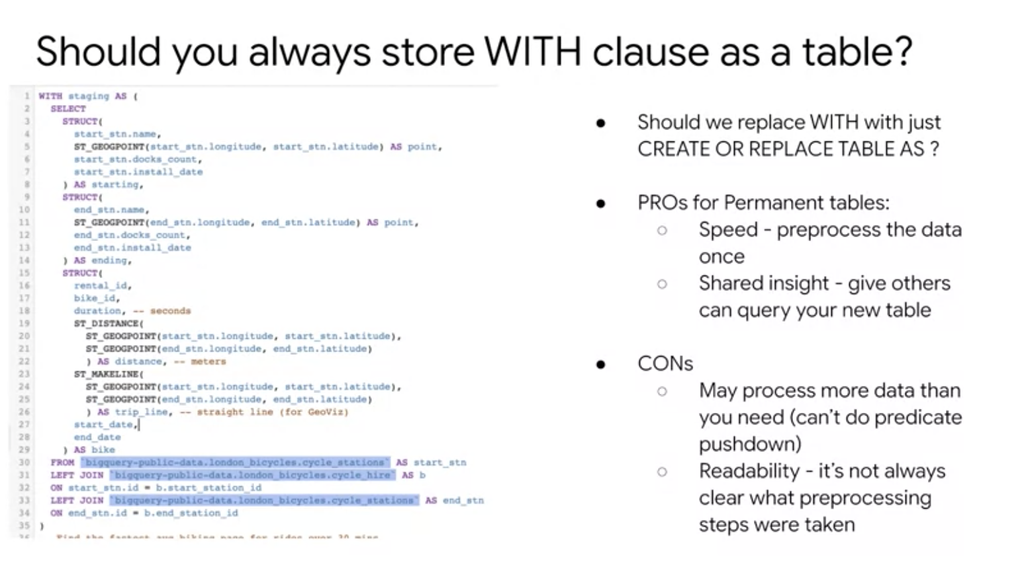

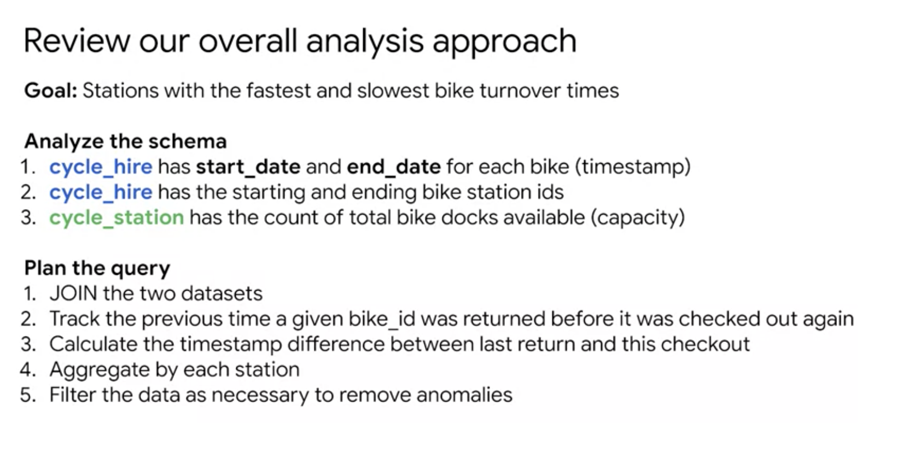

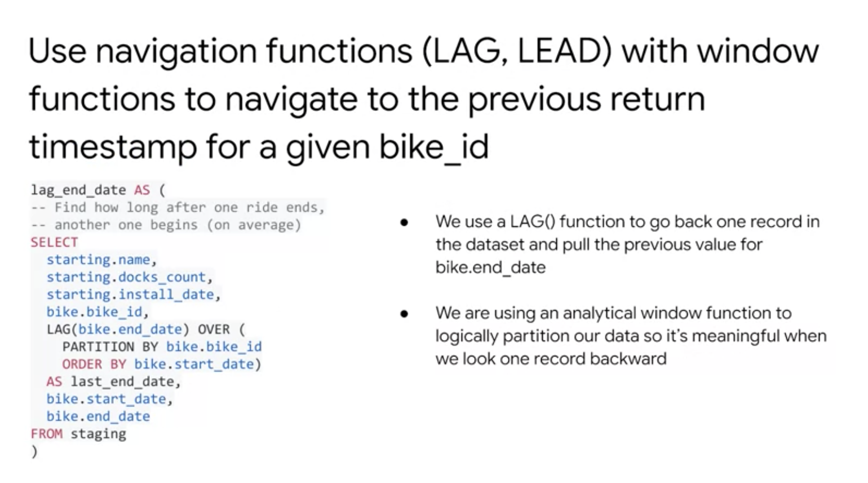

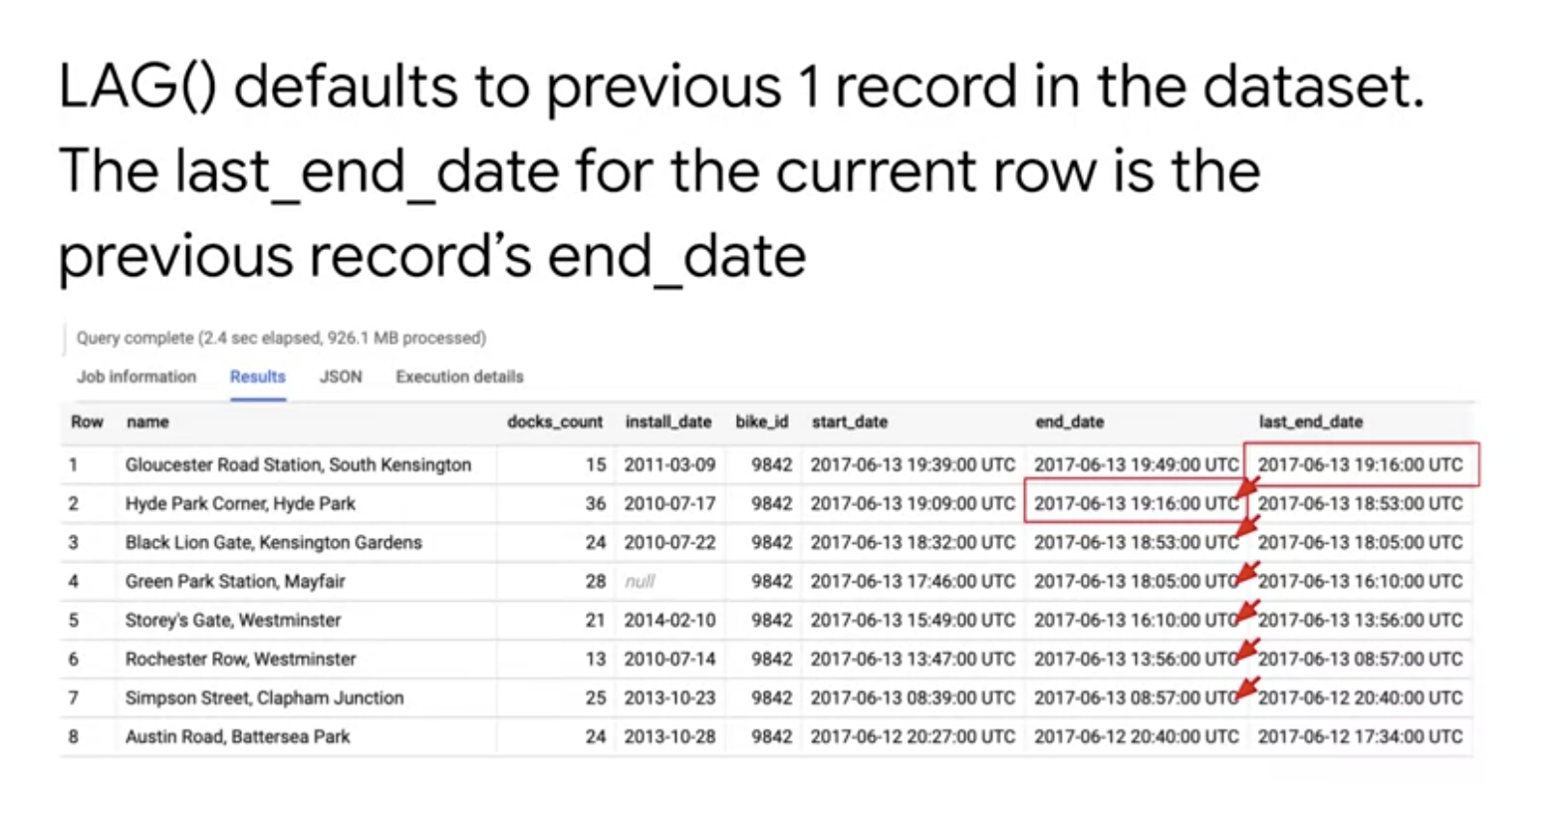

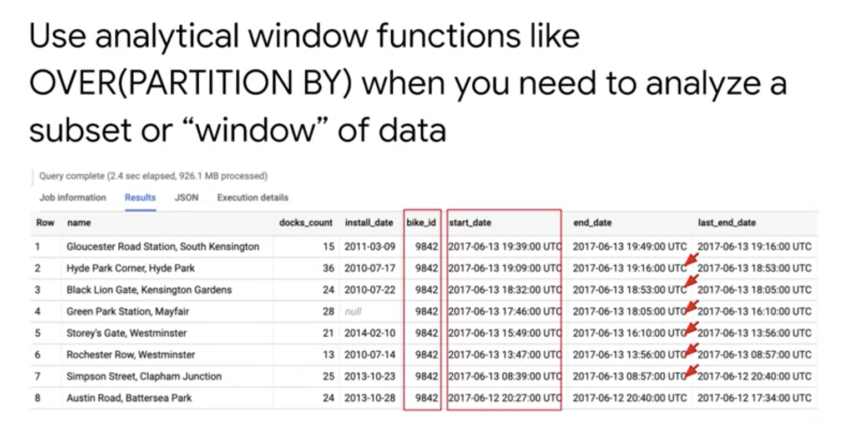

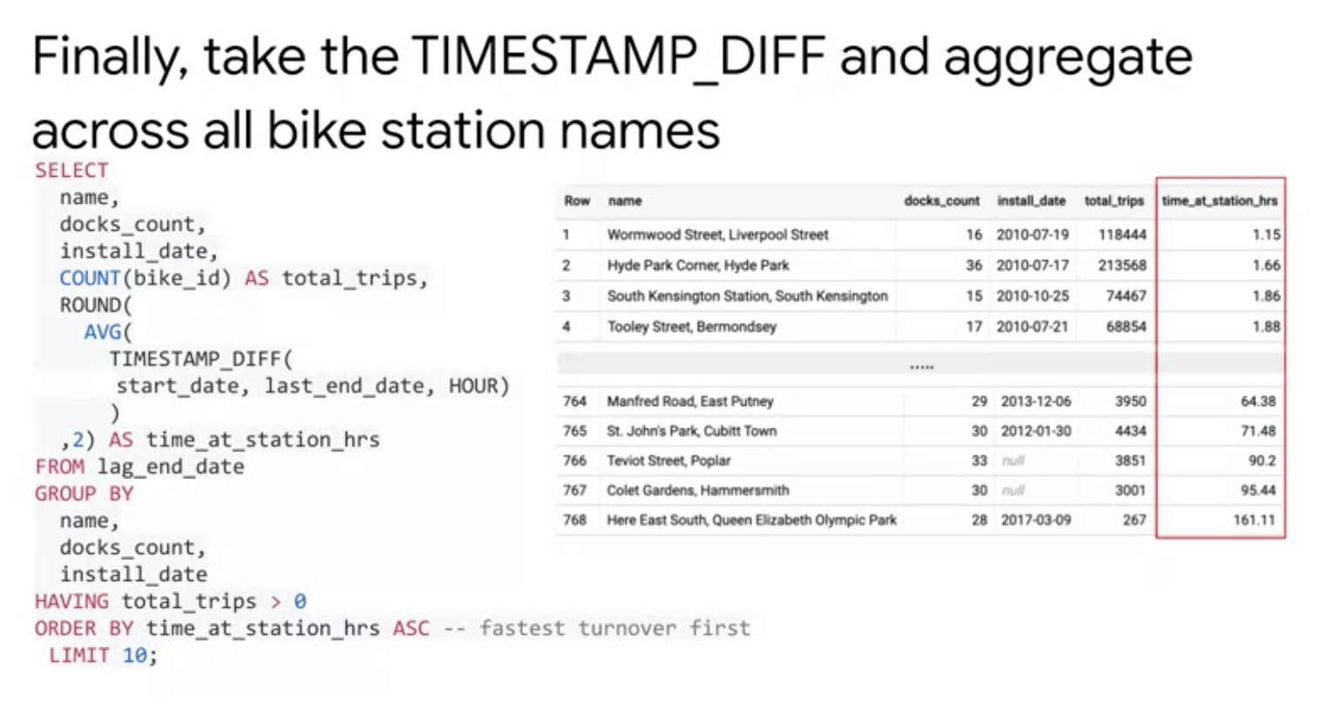

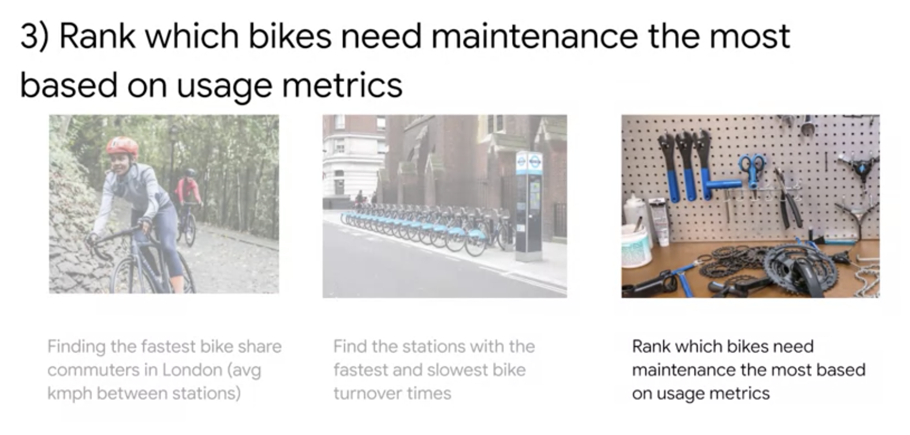

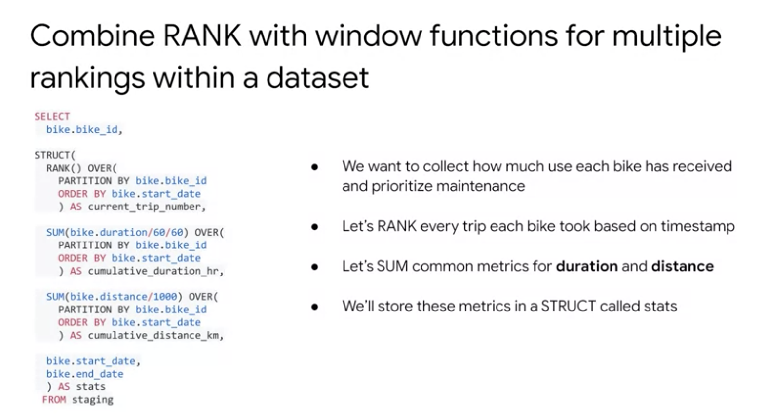

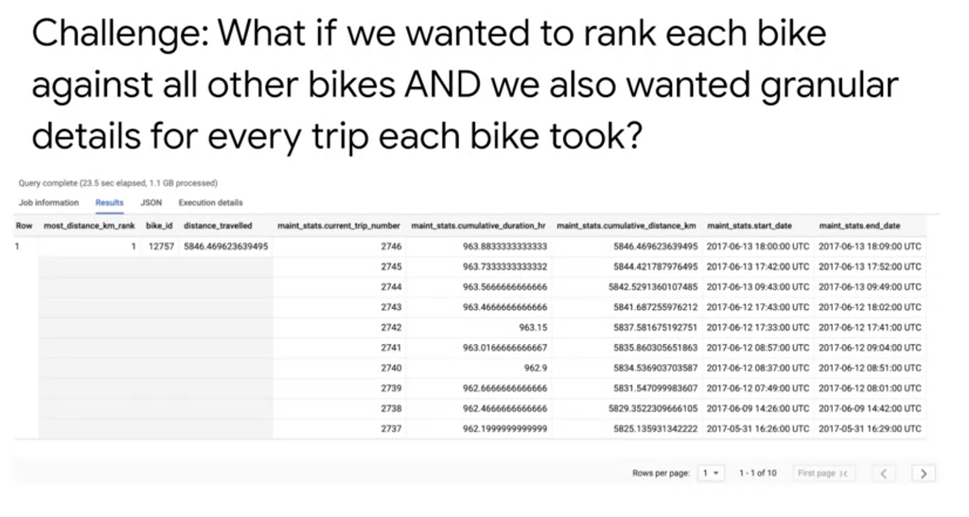

# **Performance Considerations**

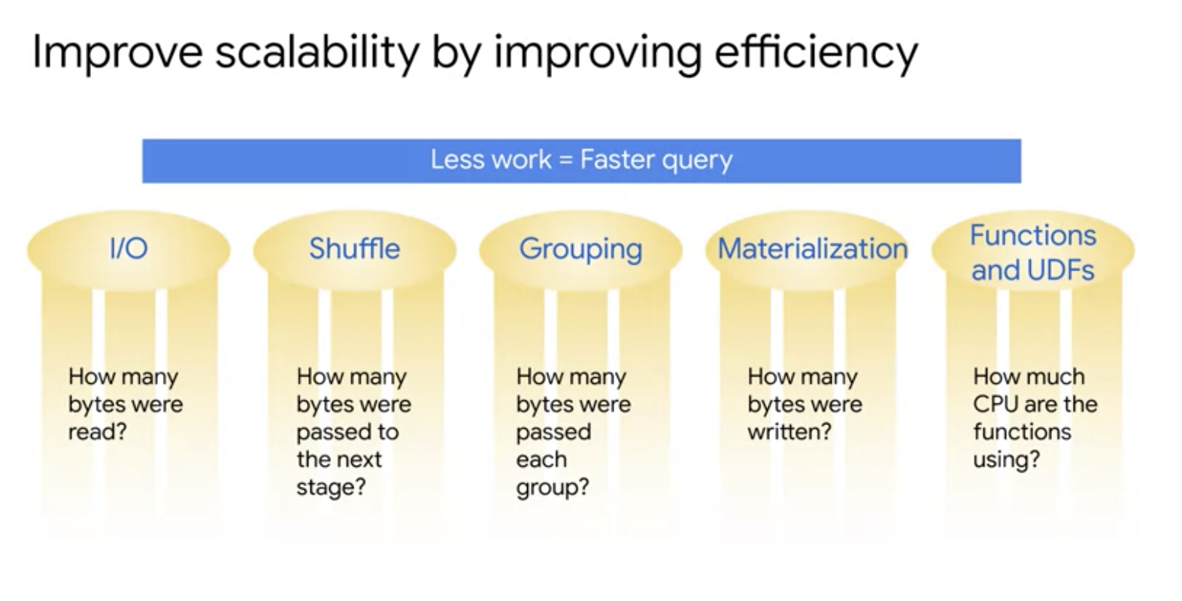

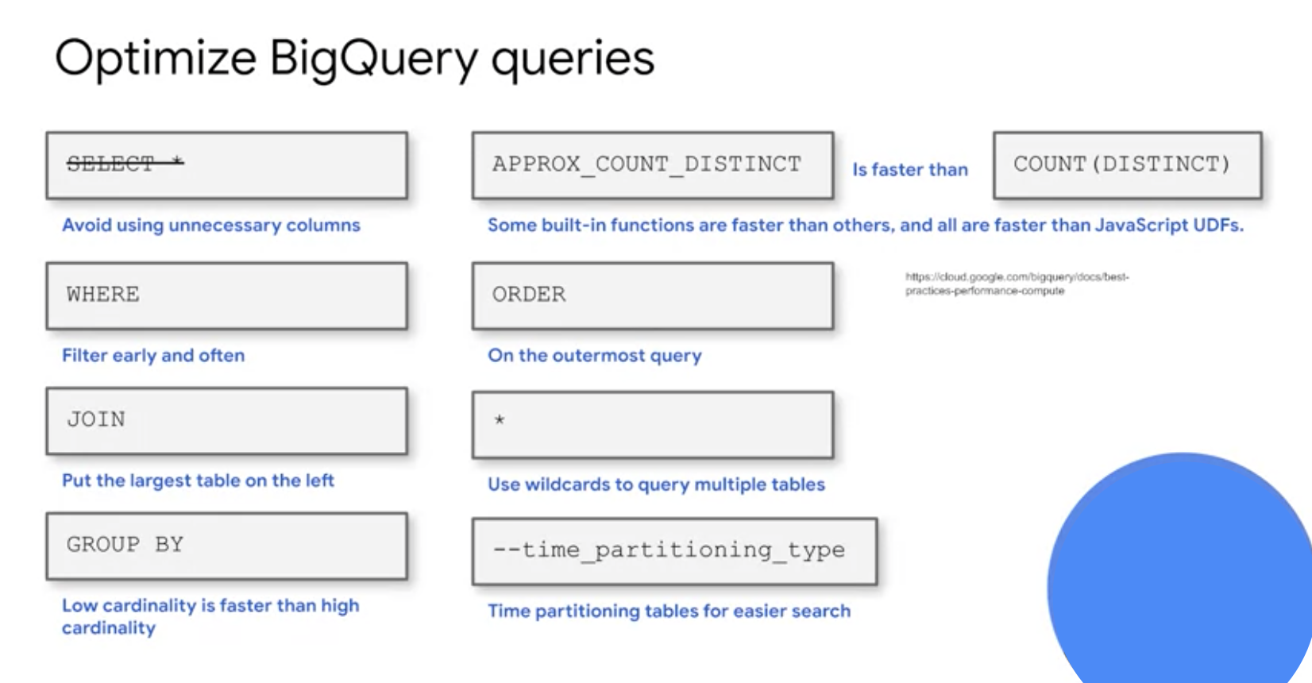

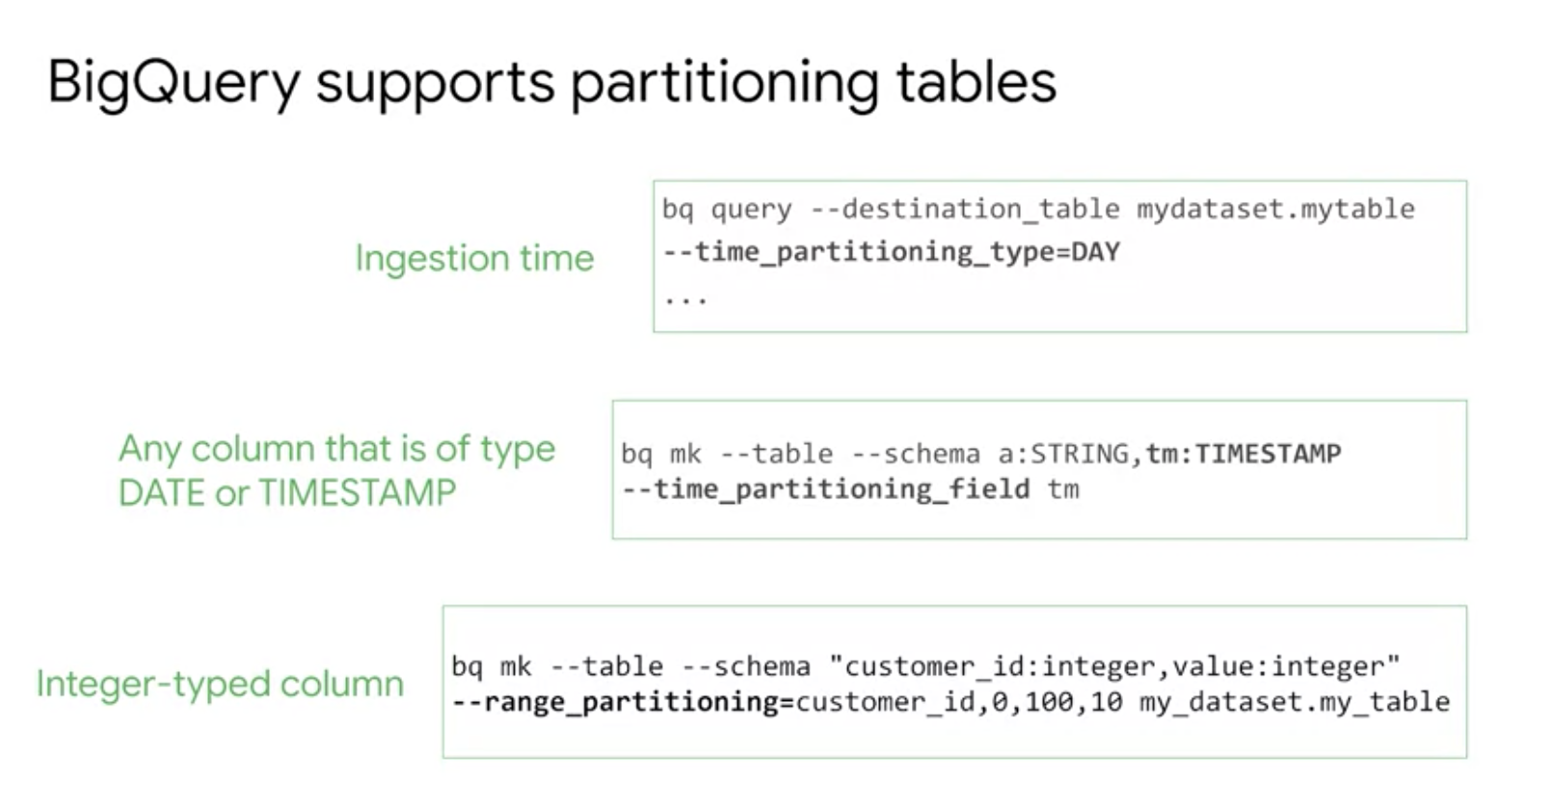

## Approximate aggregation functions

BigQuery provides fast, low-memory approximations of aggregate functions. Instead of using COUNT(DISTINCT …), we can use APPROX_COUNT_DISTINCT on large data streams when a small statistical uncertainty in the result is tolerable.

The approximate algorithm is much more efficient than the exact algorithm only on large datasets and is recommended in use-cases where errors of approximately 1% are tolerable. Before using the approximate function, measure on your use case!

### Use a window function instead of a self-join

Suppose you wish to find the duration between a bike being dropped off and it being rented again, i.e., the duration that a bicycle stays at the station. This is an example of a dependent relationship between rows. It might appear that the only way to solve this is to join the table with itself, matching the end_date of one trip against the start_date of the next.

SELECT

bike_id,

start_date,

end_date,

TIMESTAMP_DIFF( start_date, LAG(end_date) OVER (PARTITION BY bike_id ORDER BY start_date), SECOND) AS time_at_station

FROM

`bigquery-public-data`.london_bicycles.cycle_hire

LIMIT

5